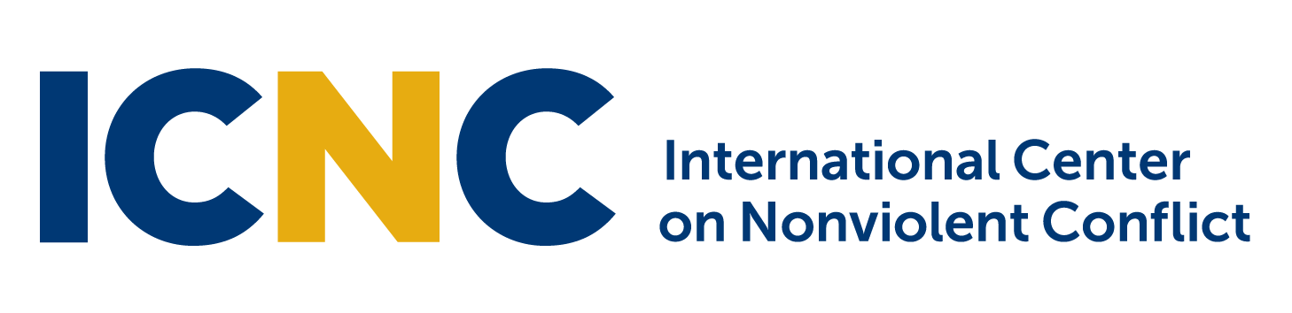

Global Field Initiatives Internship Position

The International Center on Nonviolent Conflict (ICNC) is an independent, non-profit, educational foundation that develops and encourages the study and use of nonviolent civil resistance to establish and defend human rights, democracy and justice worldwide. For more information see: www.nonviolent-conflict.org

Location: International Center on Nonviolent Conflict, Washington, DC
Anticipated start date: March 15, 2017
Duration: Until September 1, 2017; Part time: 20-25 hours per week average (paid)
Application instructions: Visit http://bit.ly/FieldIntern2017 and fill out the online application form
Application deadline: February 27, 2017. Applications will be reviewed on a rolling basis.
__________________________________________________________________________________

ABOUT ICNC:
The International Center on Nonviolent Conflict (ICNC) is seeking a Global Field Initiatives Intern to contribute to and support ICNC’s work with practitioners and activists worldwide. We are an independent, globally-oriented educational foundation that develops and disseminates knowledge about how people can organize themselves and engage in nonviolent civil resistance to fight for rights, freedom, and justice. We communicate this knowledge to educators, organizers and activists, civil society organizations, journalists and media, and the independent policy community throughout the world.

Since our founding in 2002, ICNC has pursued its mission by organizing intensive advanced summer institutes (for international professionals and activists), educational seminars, field seminars and workshops; and by supporting cutting edge research, writing, translations and the development of other programs and educational resources.

SCOPE OF WORK:

The intern will work closely with the Associate Director (AD), Global Field Initiatives, to assist in programs, grants, organizing and outreach involving practitioners and activists around the world. Specific duties include:

- Supporting the Learning Initiatives Network program by tracking reports and deliverables and supporting communication and capacity building with fellows.
- Supporting upkeep of the Learning Initiatives Network online learning platform and updates to ICNC’s website about field initiatives, as needed.
- Supporting development and implementation of online learning courses for practitioners.
- Managing travel logistics, reservations, site visits, budget development and reconciliation, report writing and support of other details for trips by the AD.
- Supporting logistics and communications related to ICNC’s translation program.
- Assisting with research about ongoing and historic civil resistance movements and nonviolent conflict environments.
- Supporting research, writing and editing of articles, presentations and workshops, and curriculum development for practitioners with the AD and advisors.
- Helping coordinate ICNC collaborative work and projects, including planning meetings, logistics, and communication among partners.
- Supporting administration, tracking, communication and selection process with grantees and potential grantees for a newly developed small grants program.

EXPERIENCE AND SKILLS

Required:
- Strong interest and knowledge in the following subjects: international relations and development, human rights, conflict, peace and security, and peacebuilding studies.
- Knowledge of global geographic, political, economic, social and cultural environments.
- Experience organizing workshops, conferences, and general event management including marketing and producing marketing materials, travel logistics, tracking registration and follow-up communication, and strong attention to detail.
- Basic technical skills, including social media expertise with Twitter, Facebook, and YouTube, as well as basic edits on websites.
- Experience producing or tracking budgets.
- Good communication skills including via Skype, email and in person.
- Strong proficiency in Microsoft Word, Excel, Outlook, Google Docs. Proficiency in WordPress or experience with online curriculum administration or development is a plus.
- Recent or enrolled undergraduate or graduate student with a strong academic standing of 3.25 or higher (a copy of the most recent academic transcript will be required).
- Fluency in English, including excellent English language editing and writing skills. Bi-lingual skills preferred, especially French, Spanish and/or Arabic.
- Must have permission to work in the U.S. and must be located in the D.C. area.
- Ability to work and communicate well within a team setting.
- Ability to work in a self-directed manner with strong work ethic, experience in professional work setting and ability to produce quality work completed in a timely manner.

Strongly Preferred:
- Experience with proposal writing and review and/or tracking and monitoring grants.
- Strong writing, editing, and research skills including online, news and academic articles.
- Experience with additional academic and online platforms such as Drupal and Moodle.

Two references required: (academic and professional experience)

