ICNC 2022 Participant-Led Civil Resistance Struggles Online Course
Learning Gains Report

The graphs below are from ICNC’s 2022 Civil Resistance Struggles Participant-Led Online Course, Civil Resistance Struggles: How Ordinary People Win Rights, Freedom, and Justice. Participants were asked to complete the same survey at the beginning of the course and at the end of the course. Each survey was divided into five sections. 20 participants completed both pre- and post-course surveys.

I. Civil Resistance Skills 2
II. Effectiveness of Civil Resistance Engagement 8
III. Applicability & Relevance 13
IV. Civil Resistance Knowledge 17
V. Attitude/Belief about Civil Resistance 28
VI. Course Platform and Device 37

I. Civil Resistance Skills
Pre-Course:
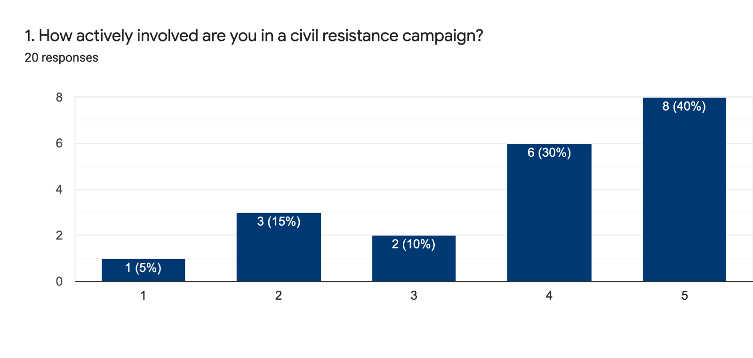1= Not active at all
5= Very active

Post-Course:
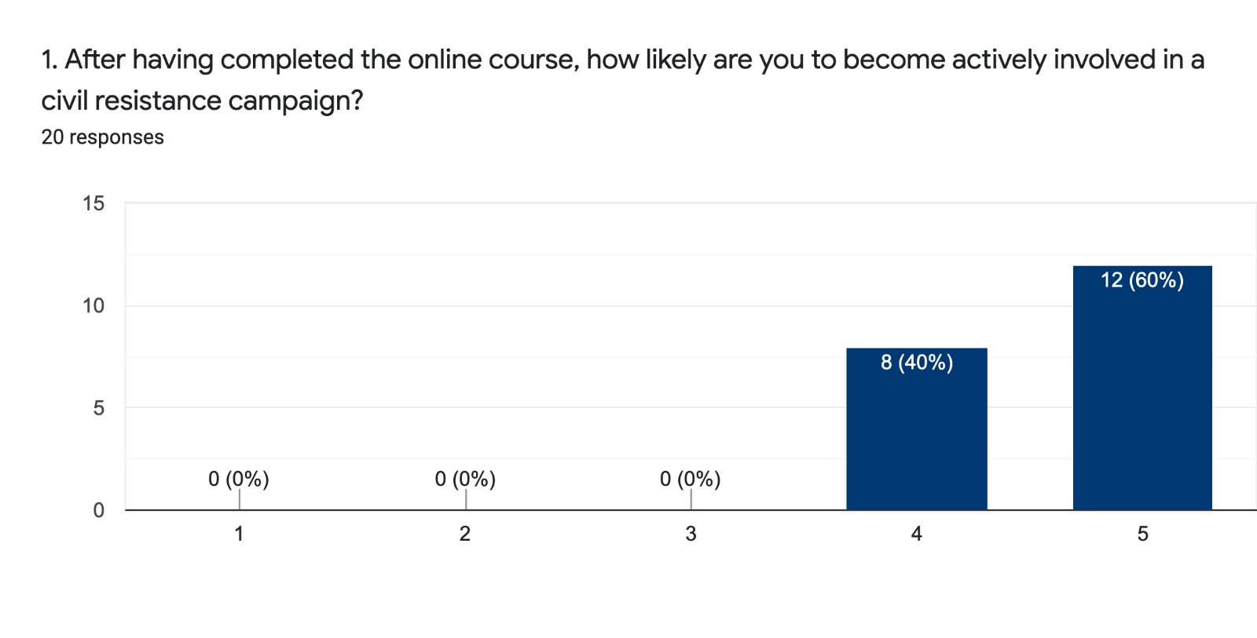1= Not at all likely
5= Very likely

Pre-Course:
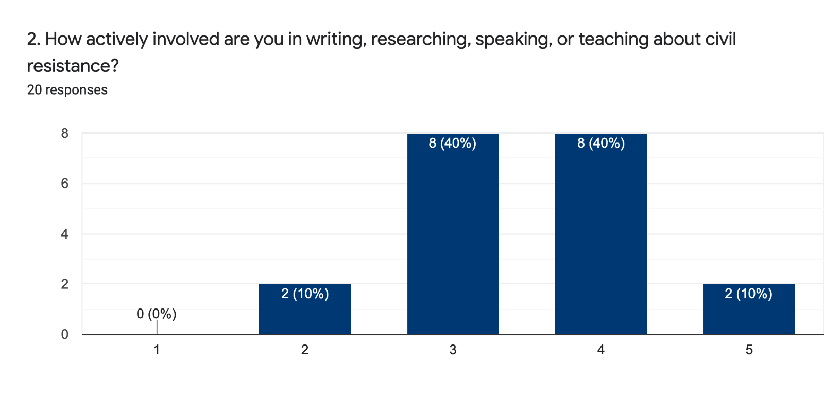1= Not active at all
5= Very active

Post-Course:
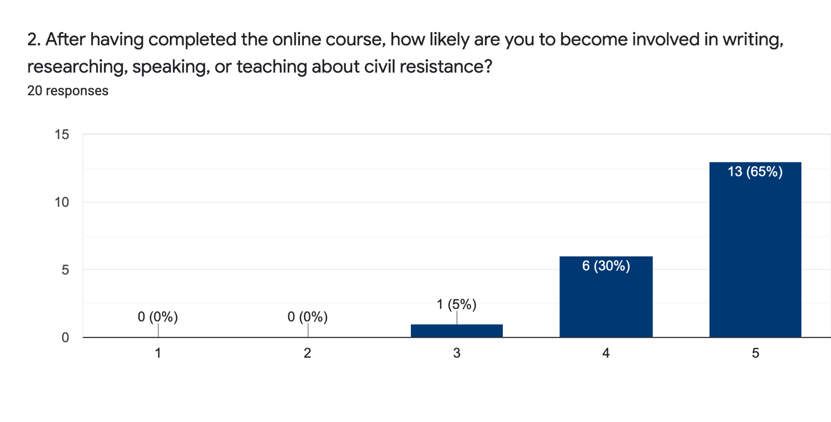1= Not at all likely
5= Very likely

Pre-Course:
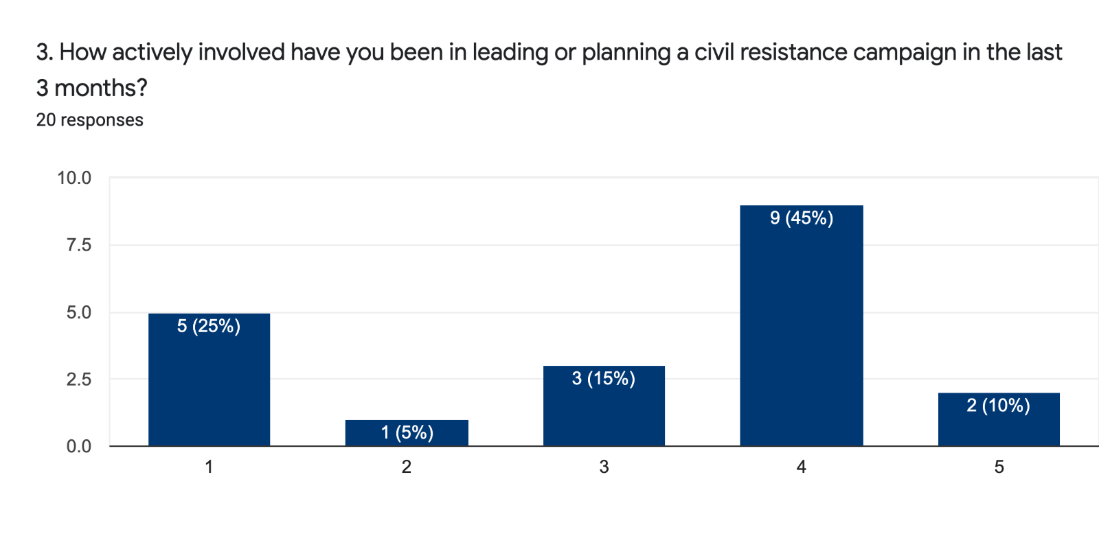1= Not active at all
5= Very active

Post-Course:
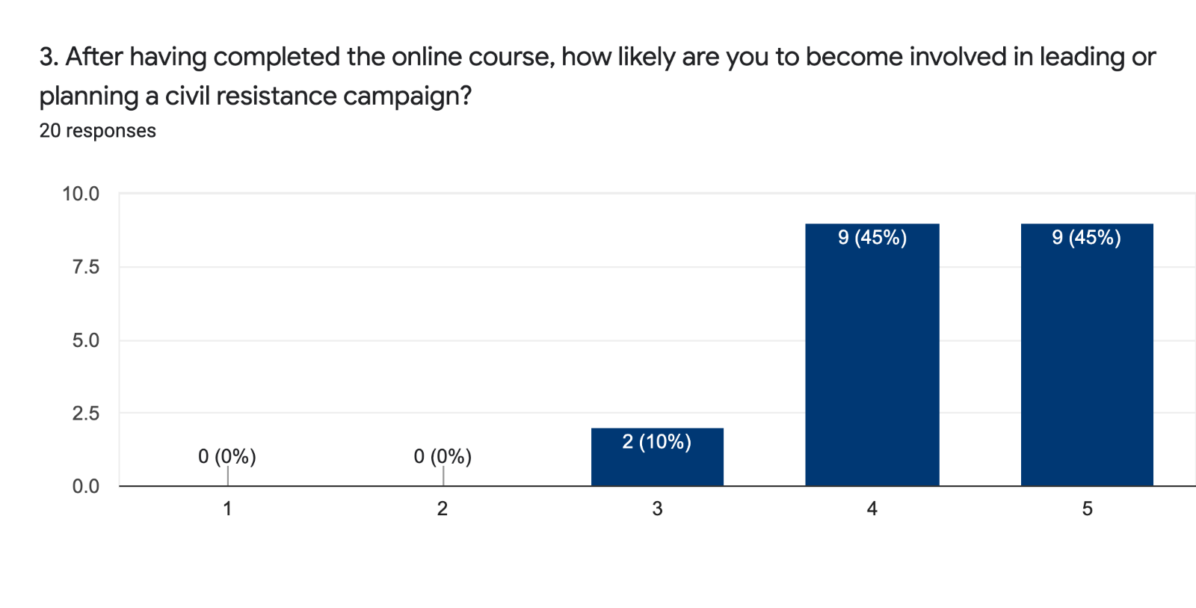1= Not at all likely
5= Very likely

Pre-Course:
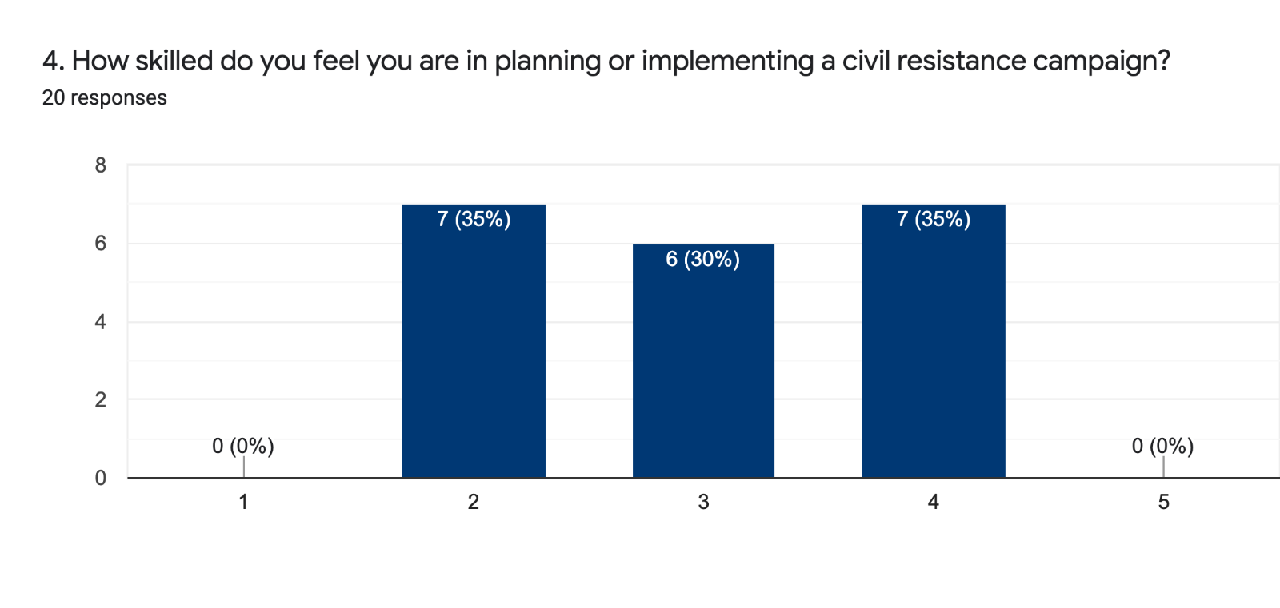1= Not skilled at all
5= Very skilled

Post-Course:
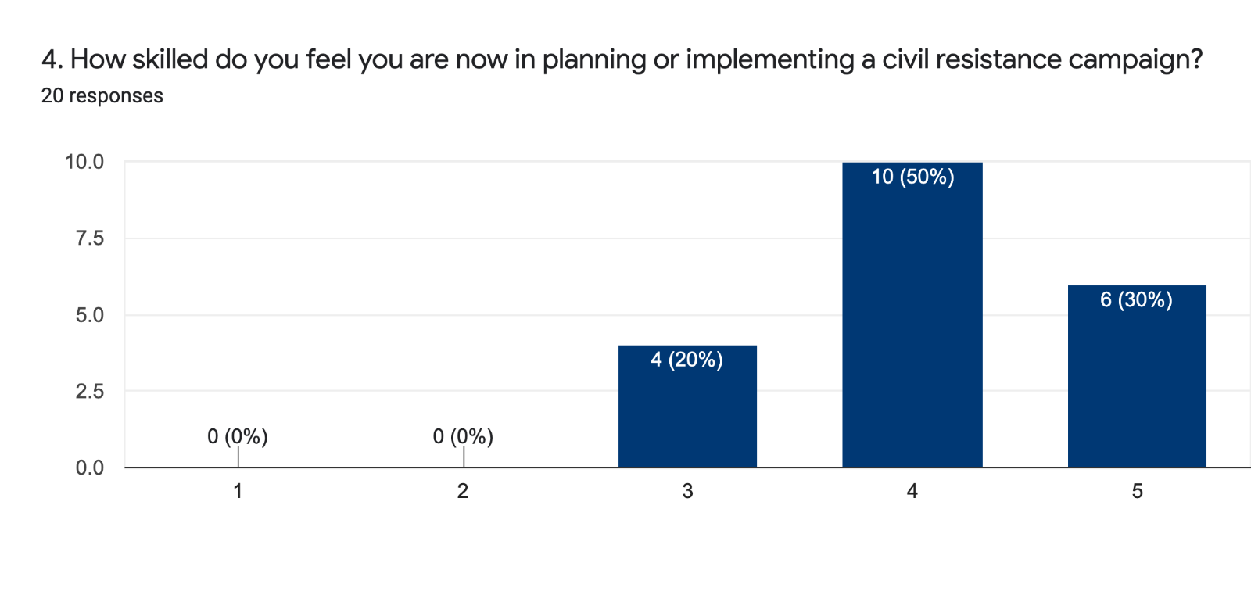1= Not at all skilled
5= Very skilled

Pre-Course:
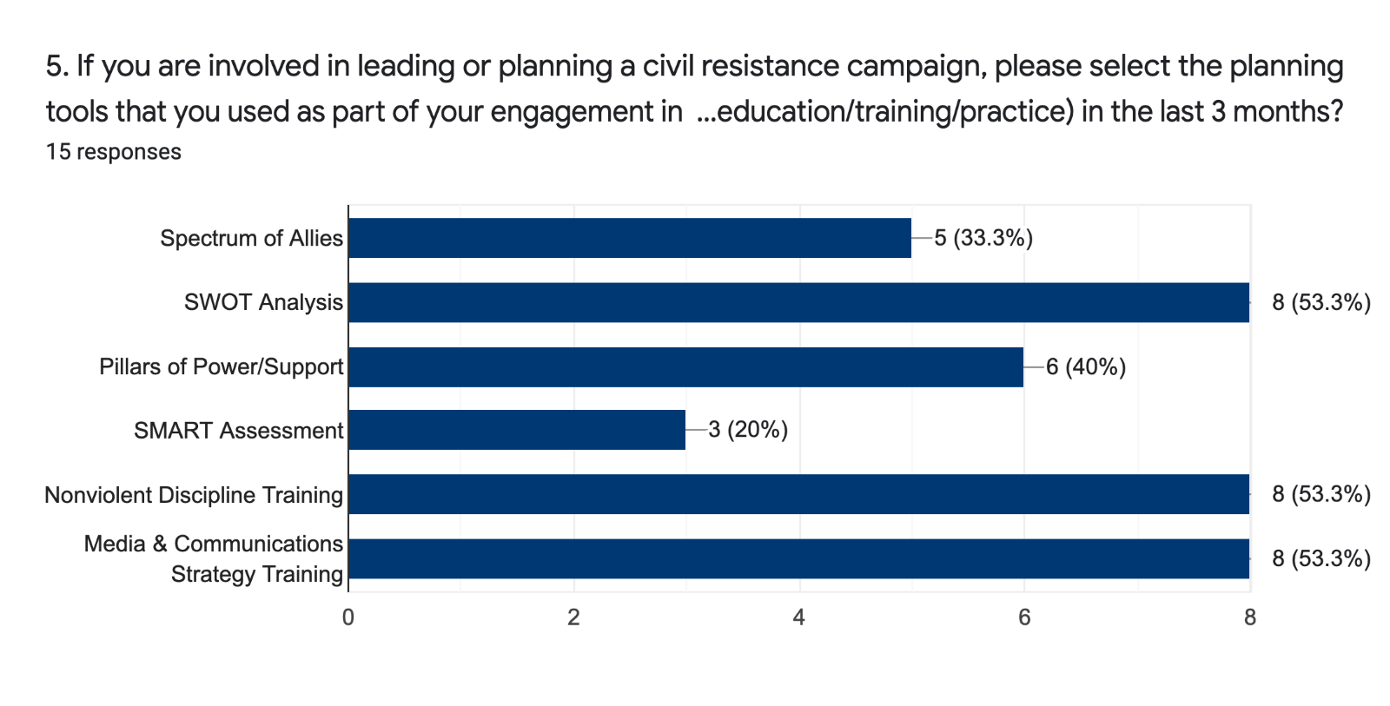
Post-Course:
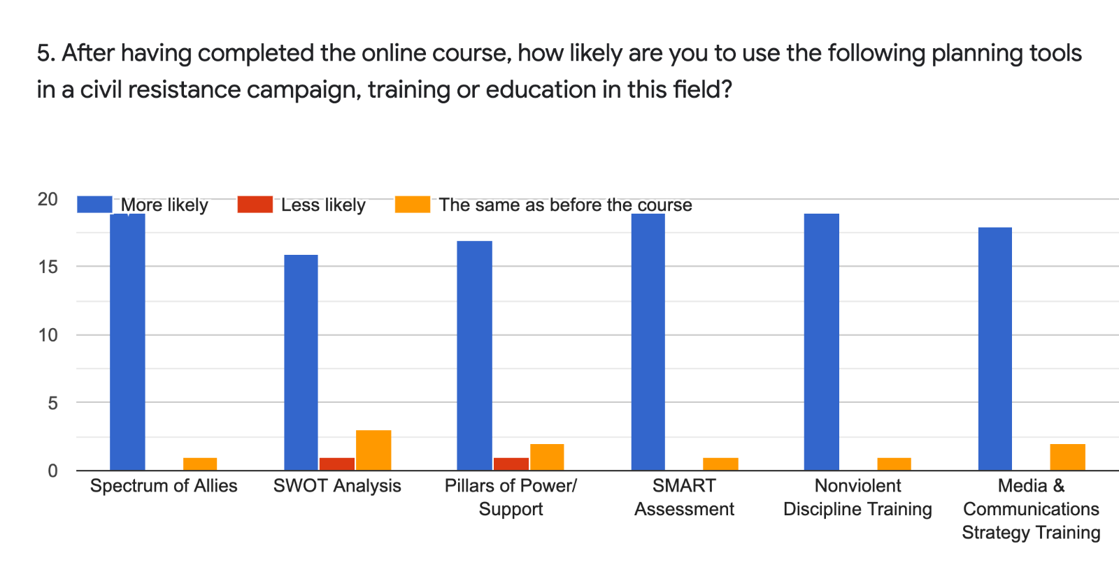
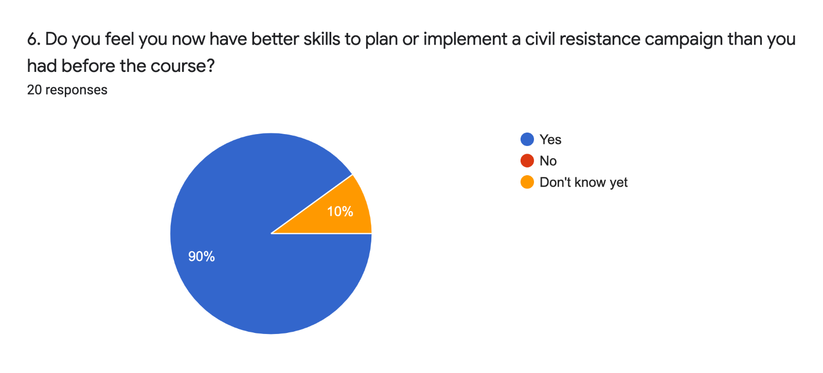

II. Effectiveness of Civil Resistance Engagement
Pre-Course:
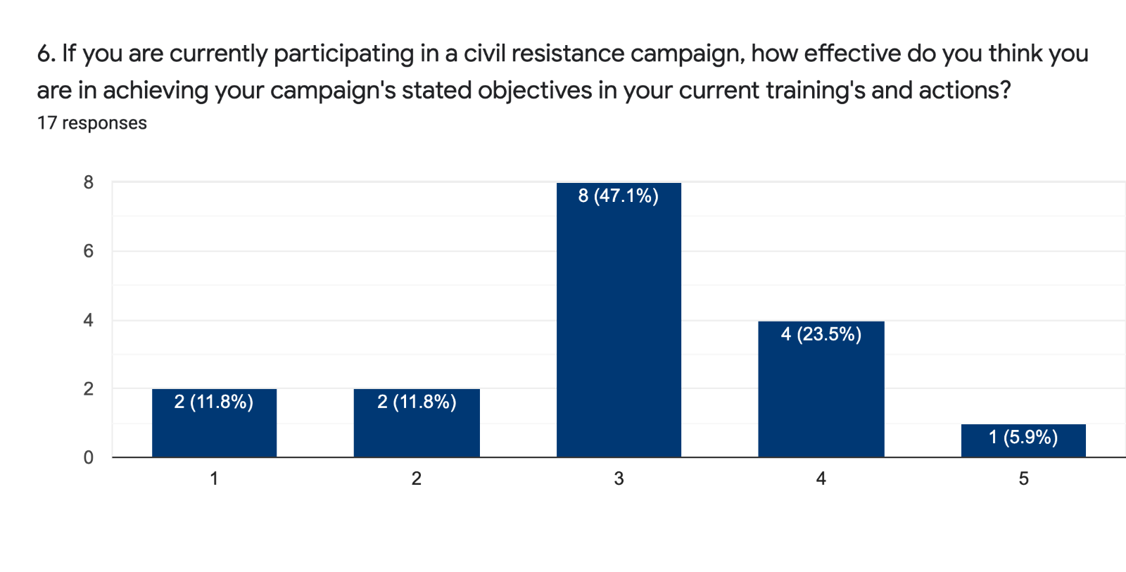1= Not effective at all
5= Very effective

Post-Course:
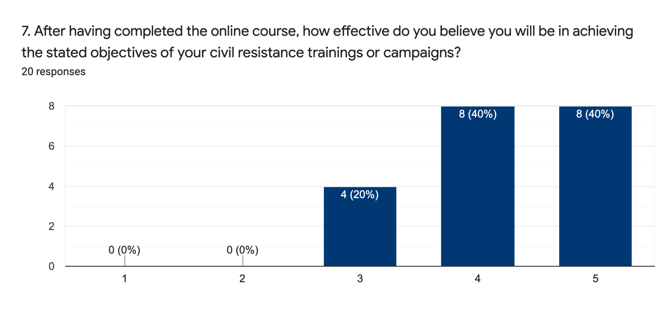1= Not effective at all
5= Very effective

Pre-Course:
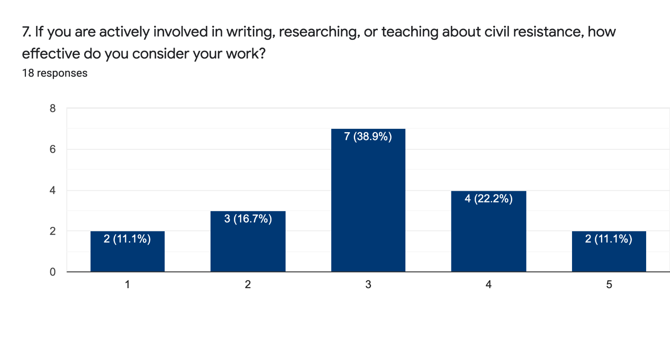1= Not effective at all
5= Very effective

Post-Course:
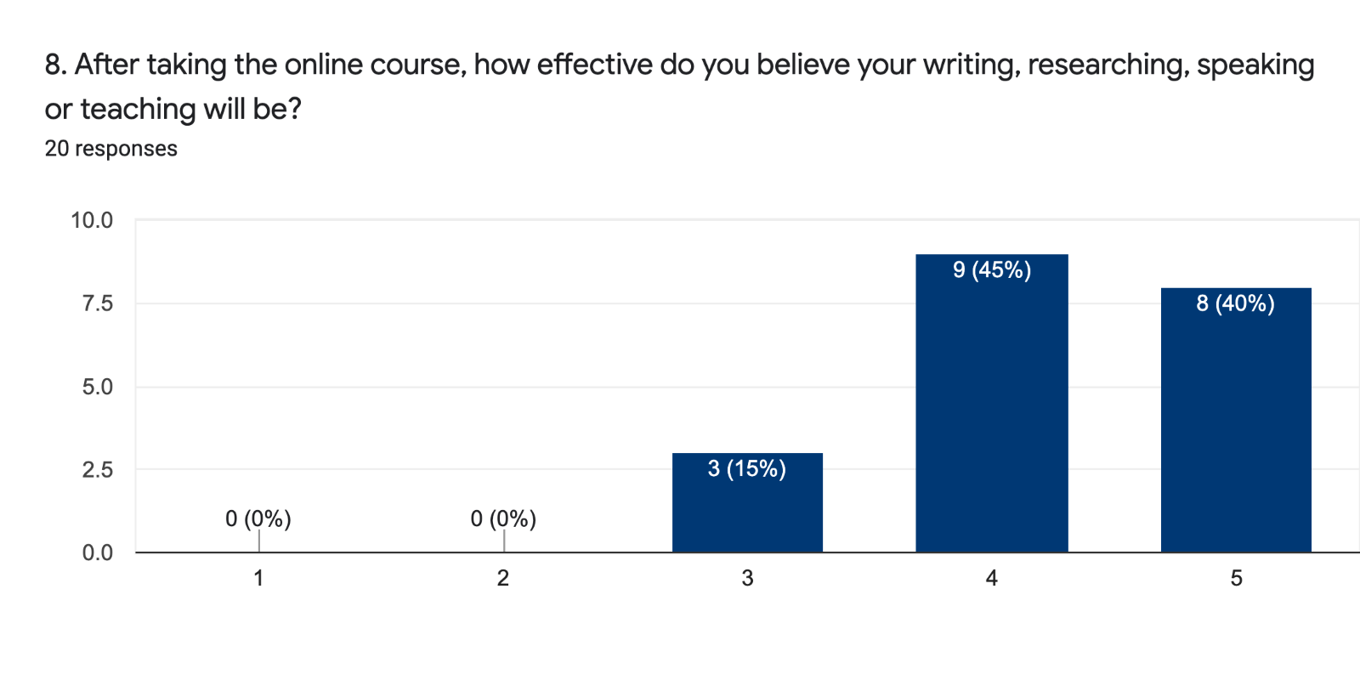
1= Not effective at all
5= Very effective

Pre-Course:
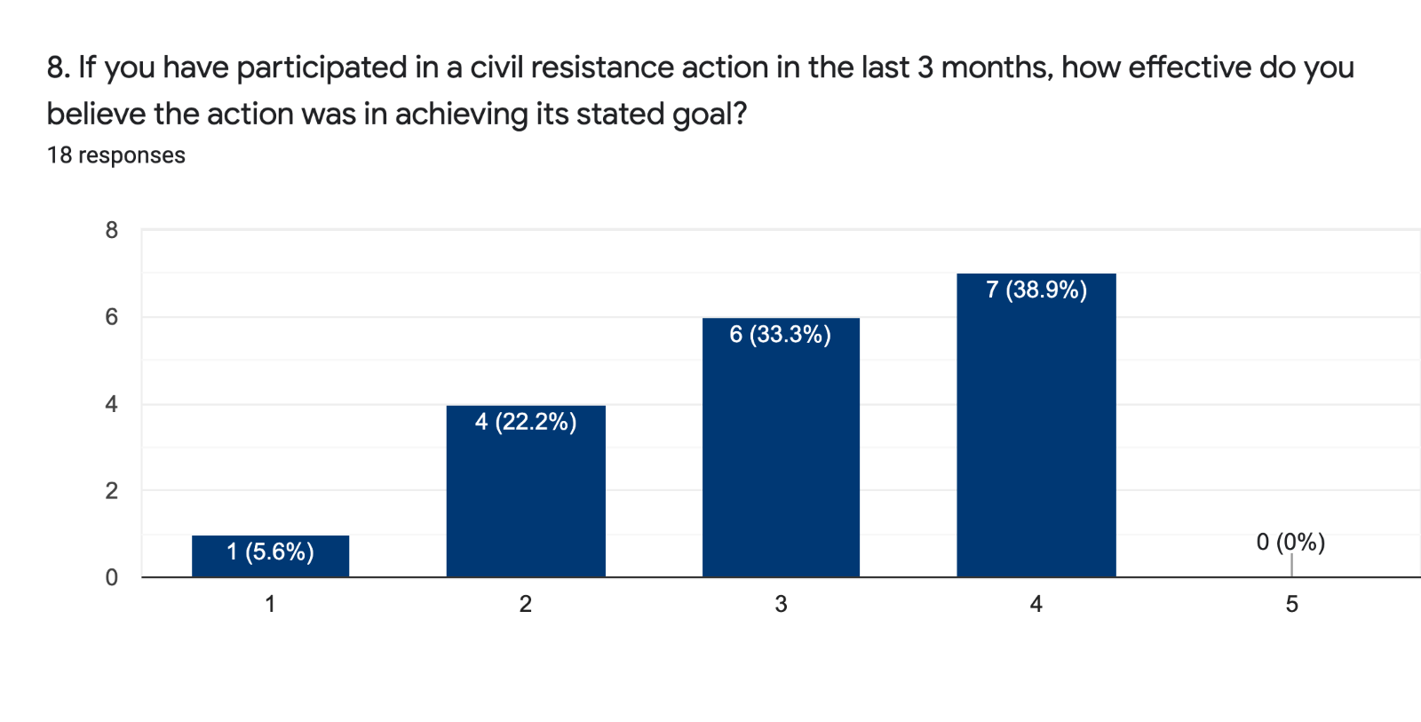1= Not effective at all
5= Very effective

Post-Course:
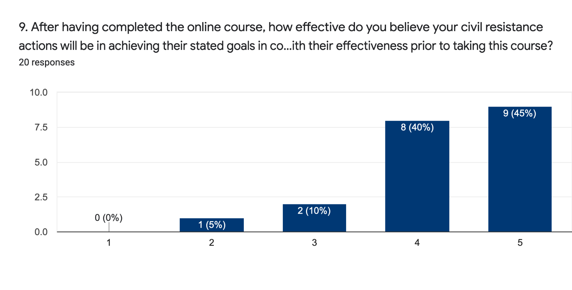1= Not effective at all
5= Very effective

Pre-Course:
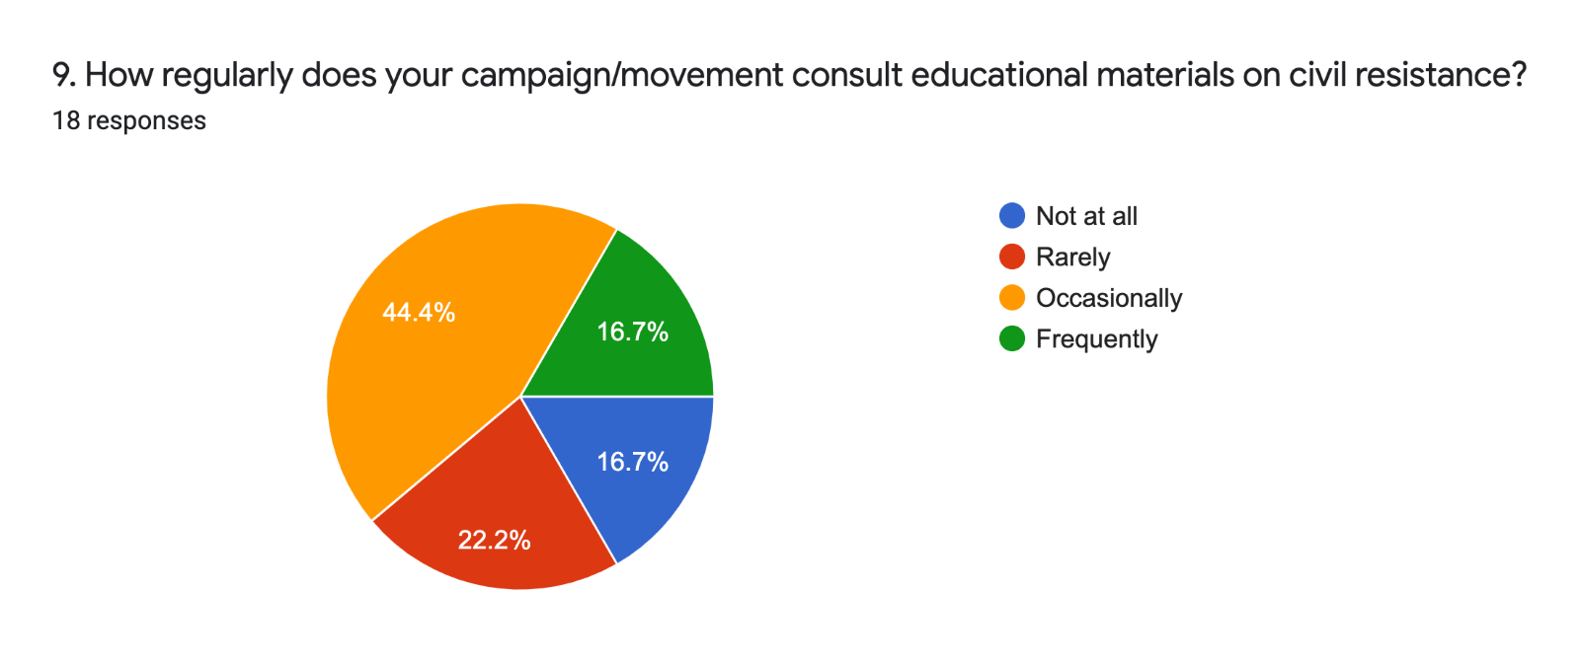

Post-Course:
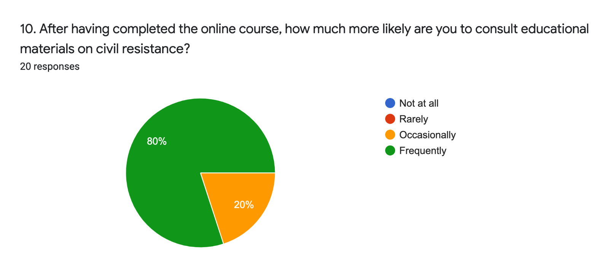

Pre-Course:
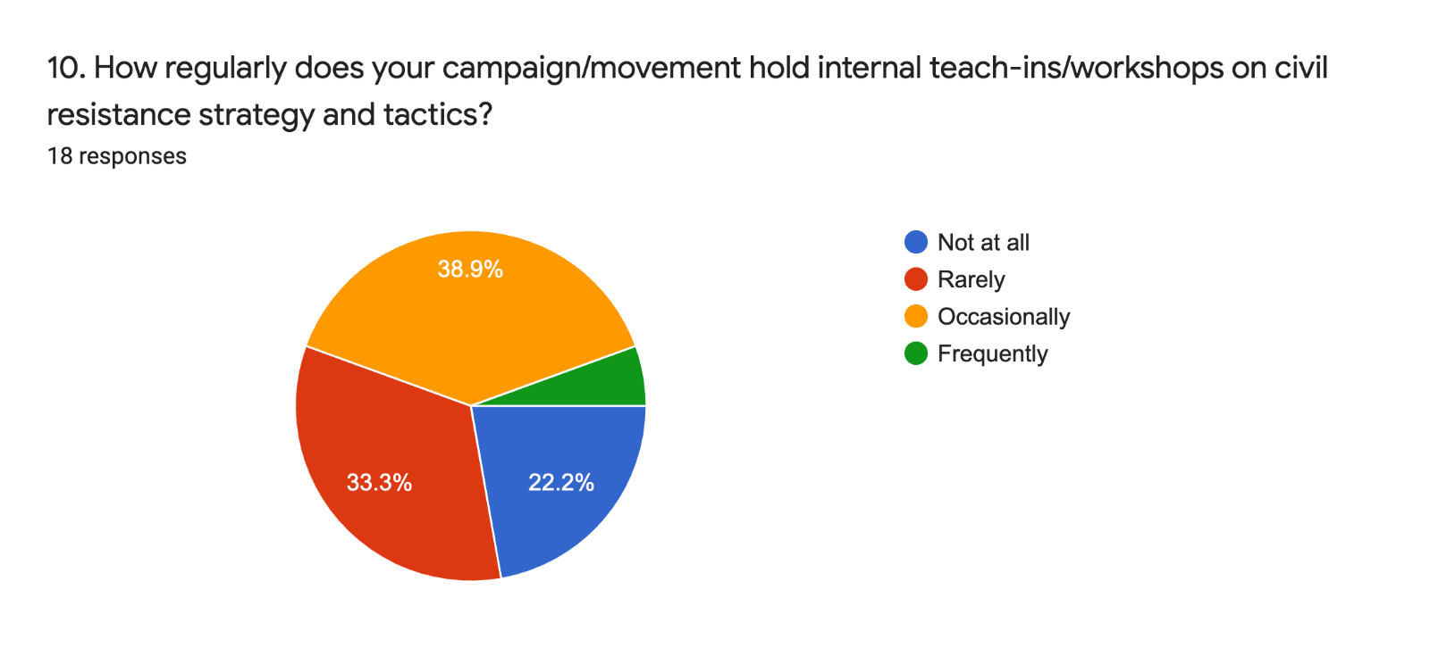
Post-Course:
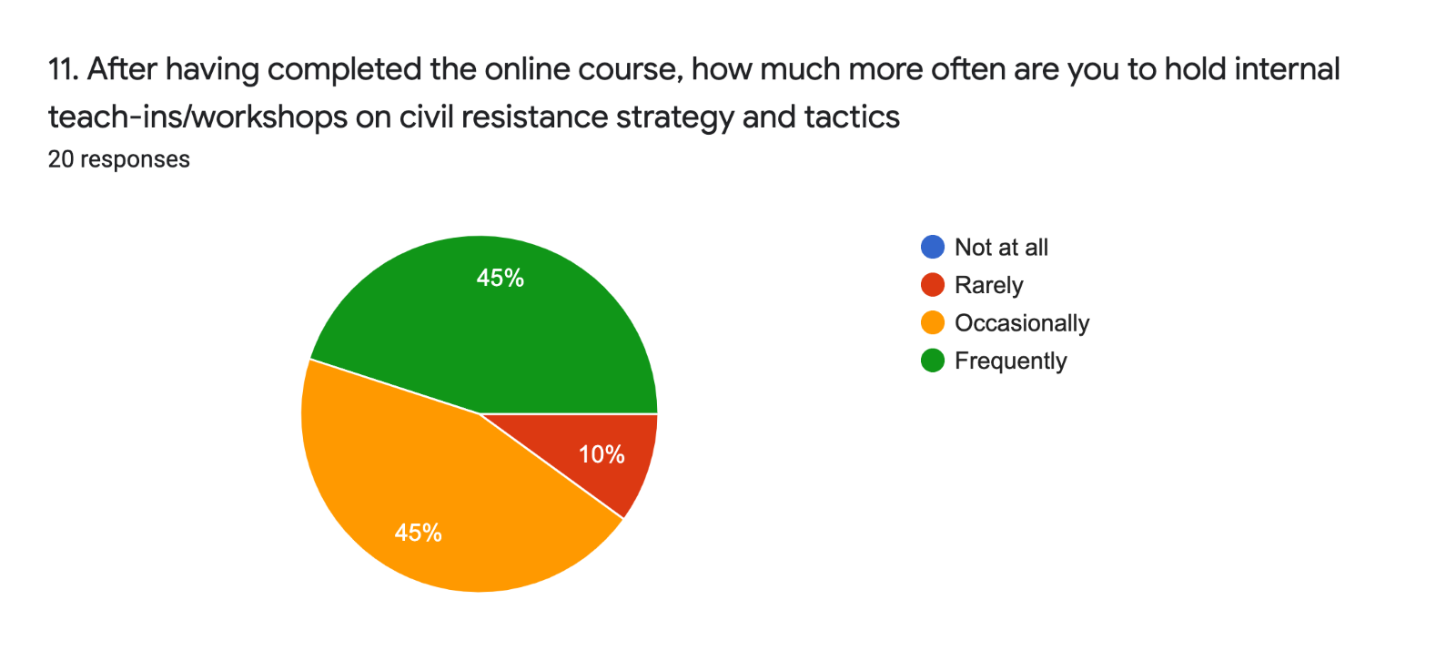

III. Applicability & Relevance
Pre-Course:
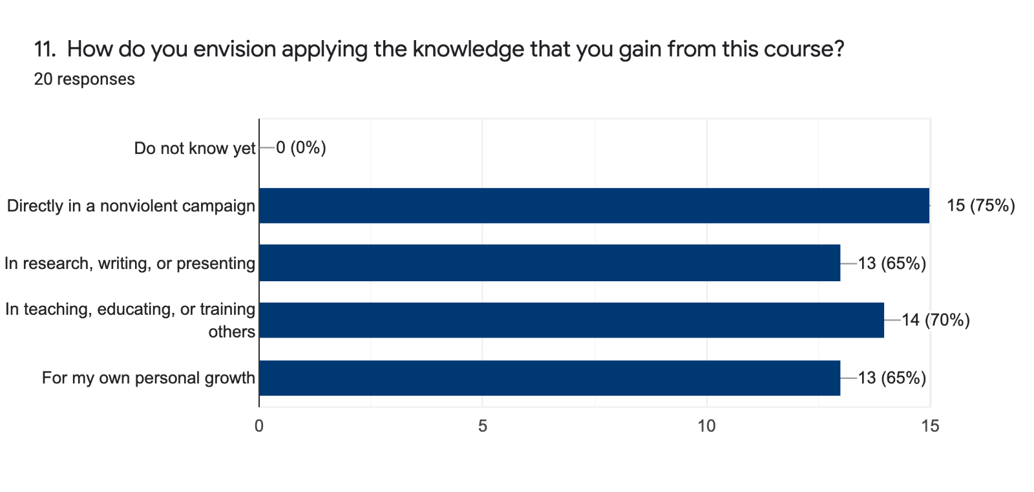
Post-Course:
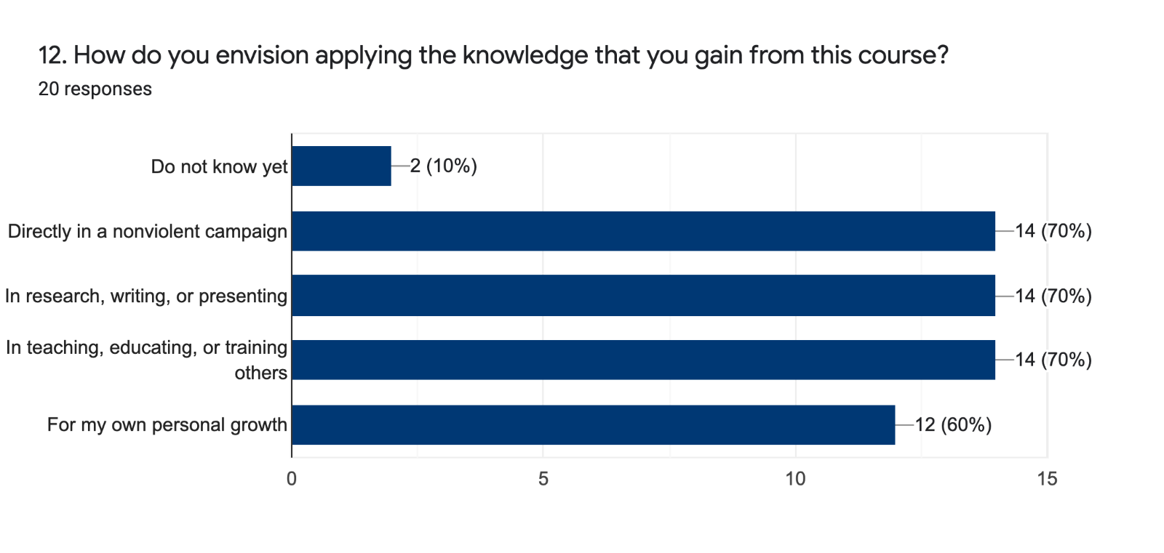

Pre-Course:
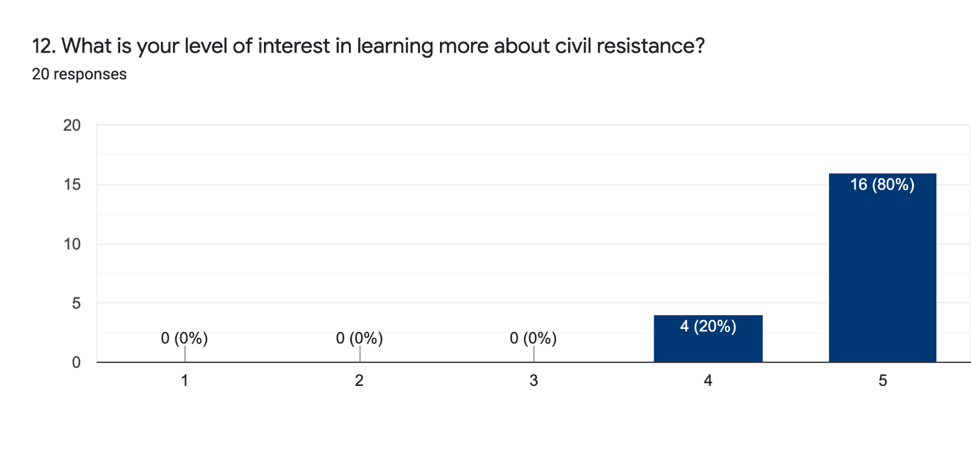
1= Not low
5= Very high

Post-Course:
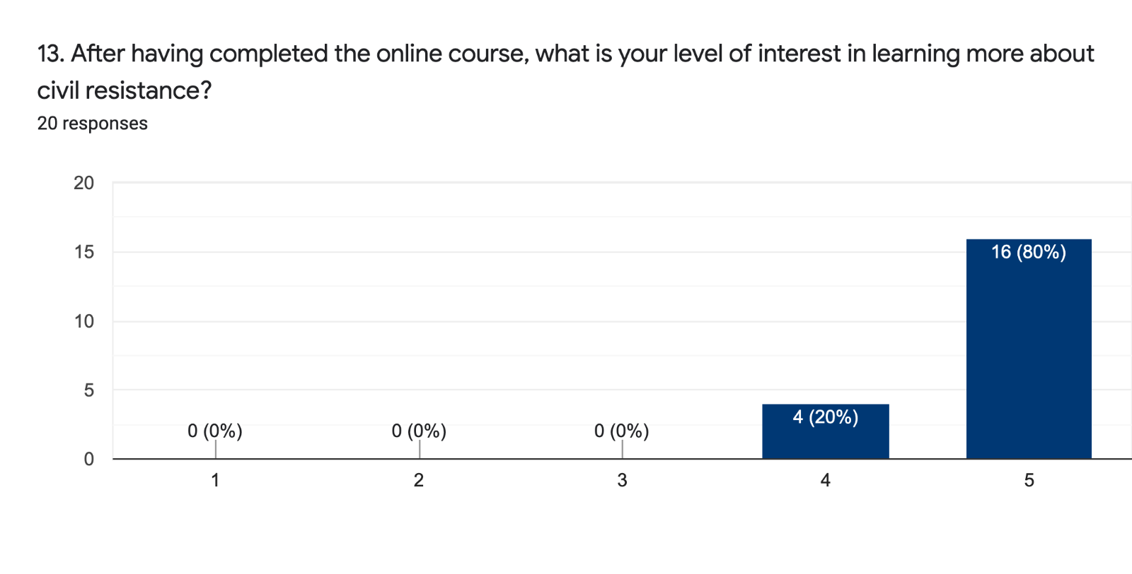1= Very low
5= Very high

Pre-Course:
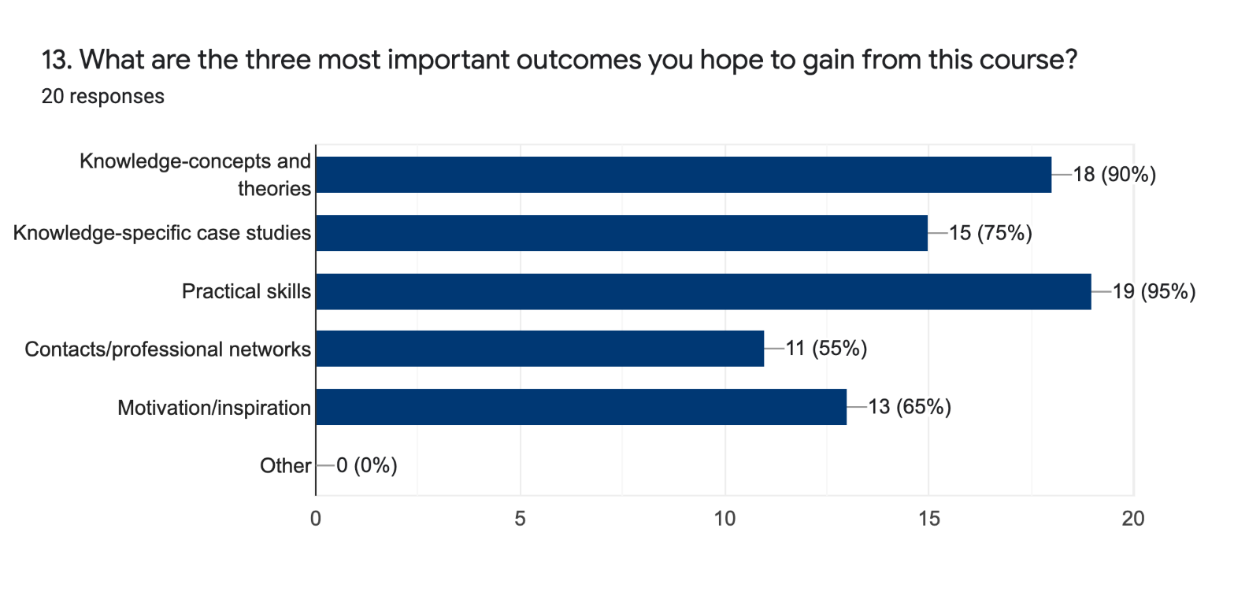

Post-Course:
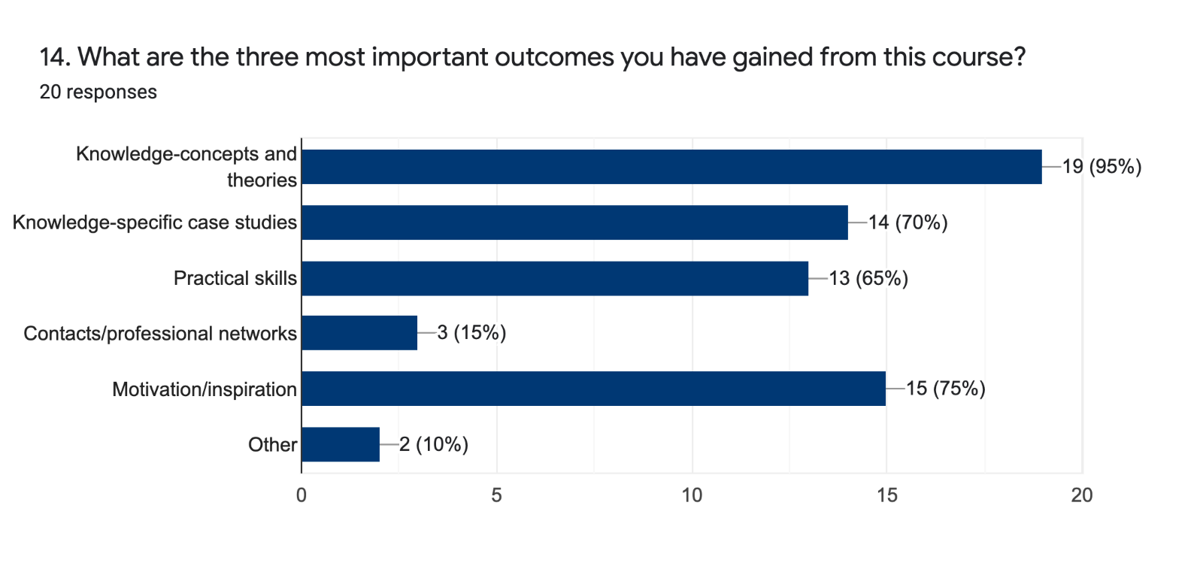

Pre-Course:
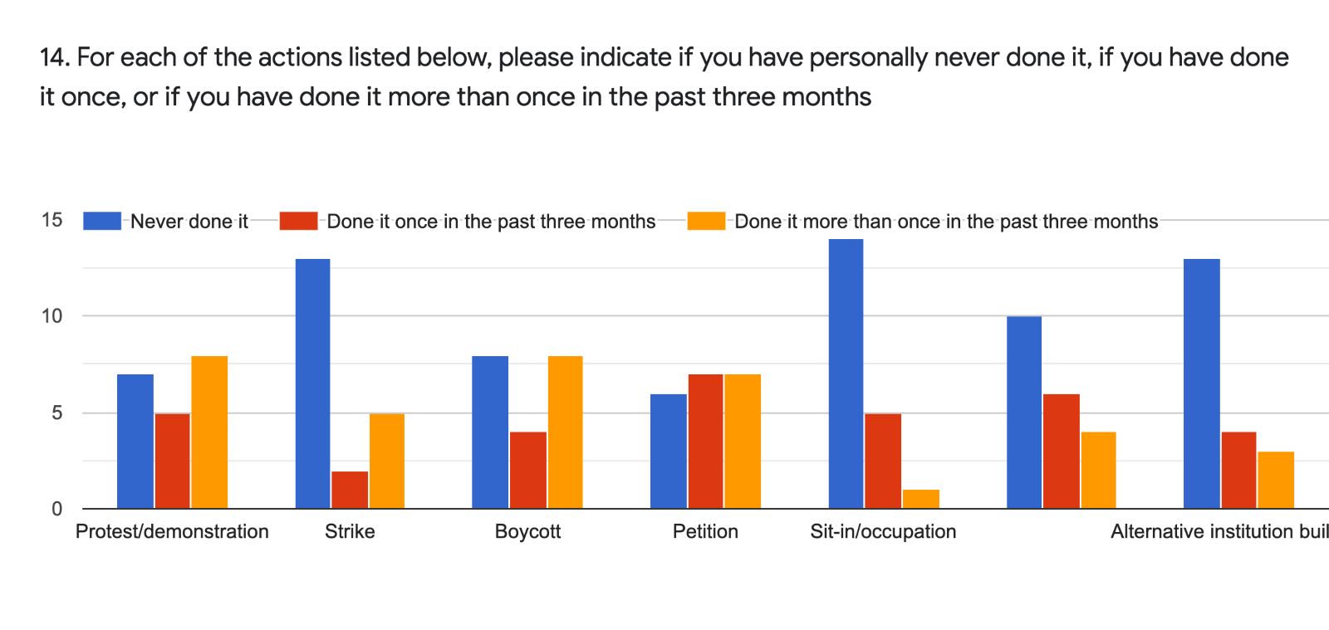

Post-Course:
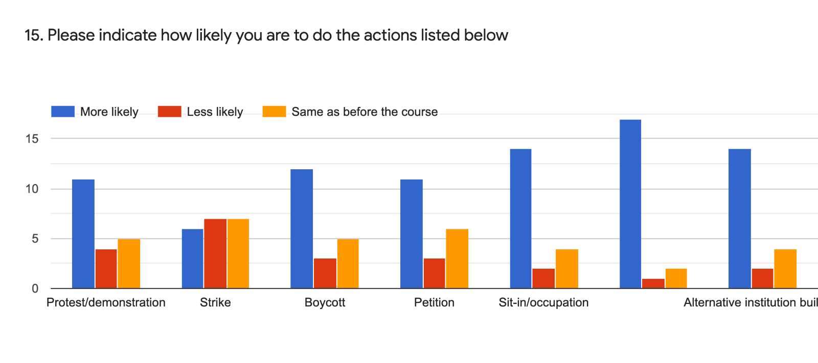

IV. Civil Resistance Knowledge
Pre-Course:
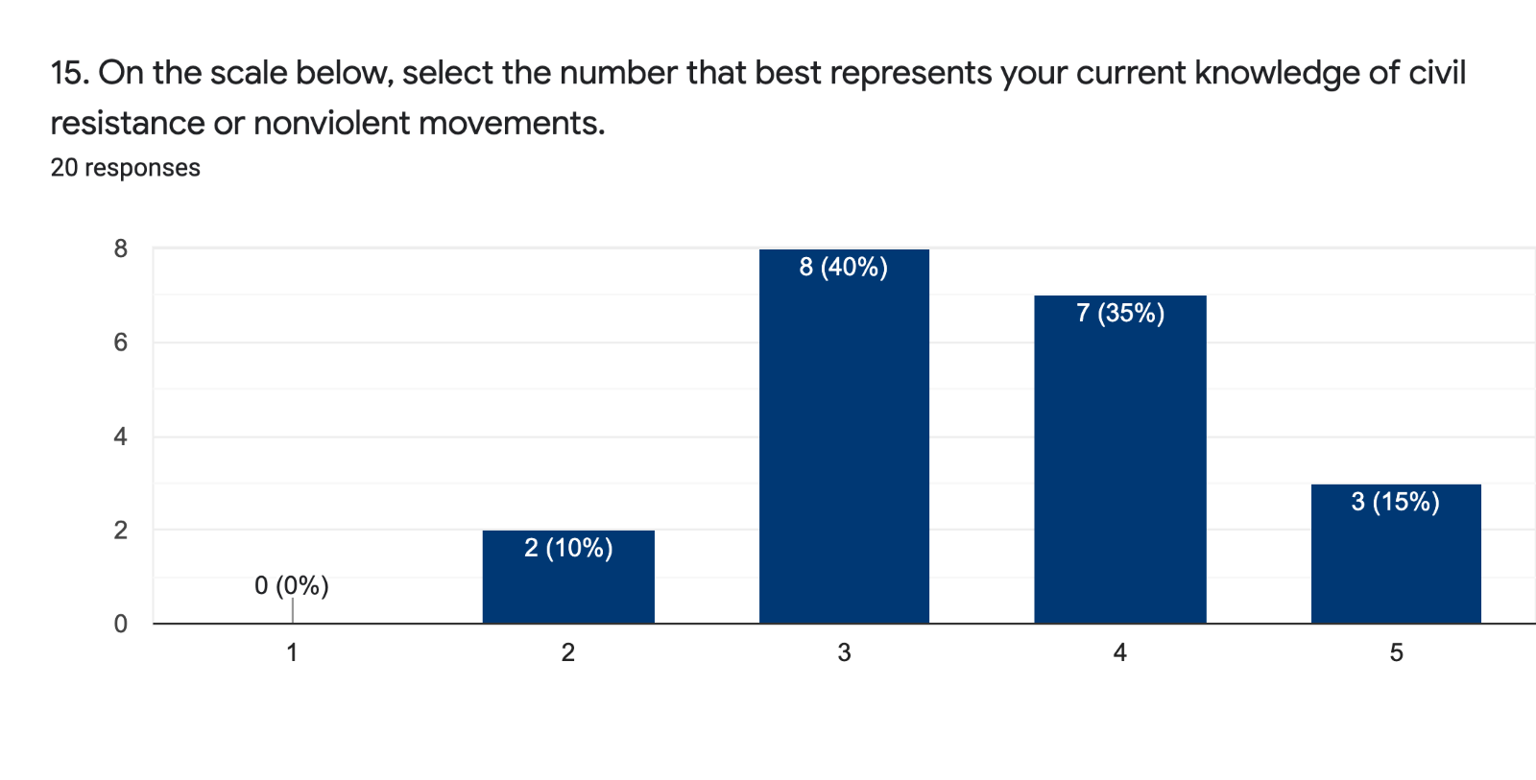
1= None
5= Very knowledgeable

Post-Course:
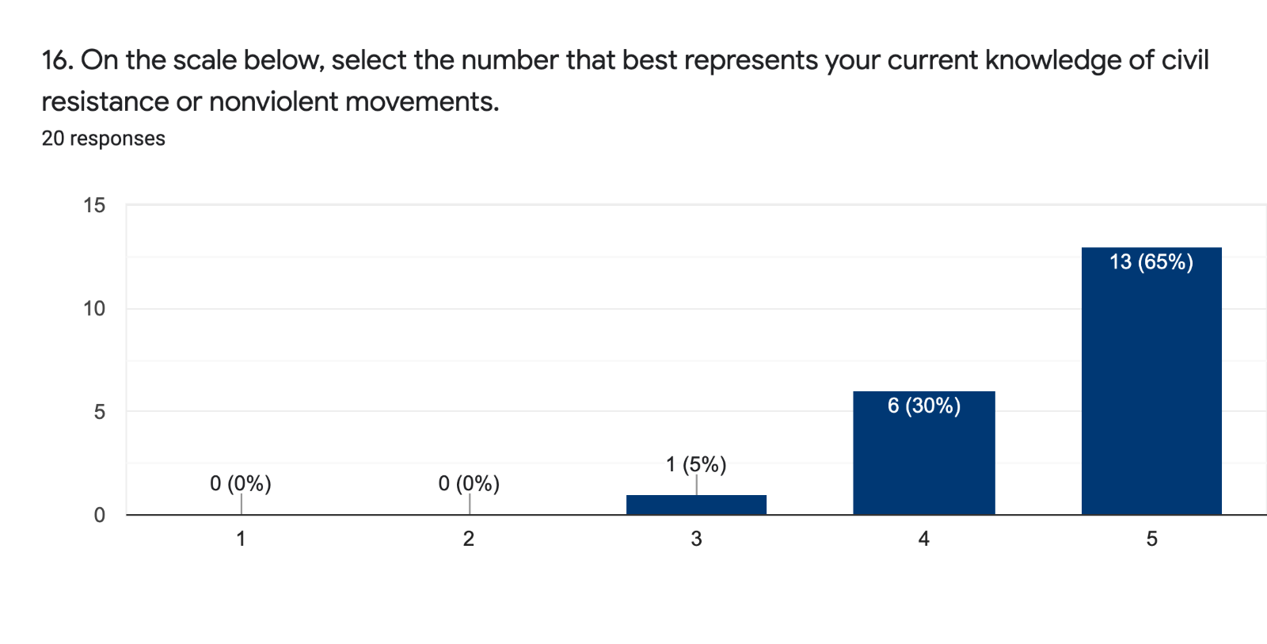1= None
5= Very knowledgeable

Pre-Course:
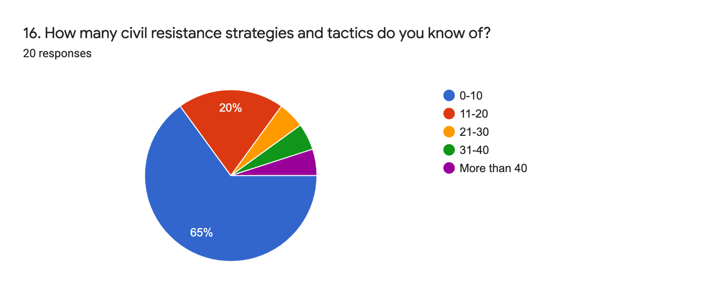

Post-Course:
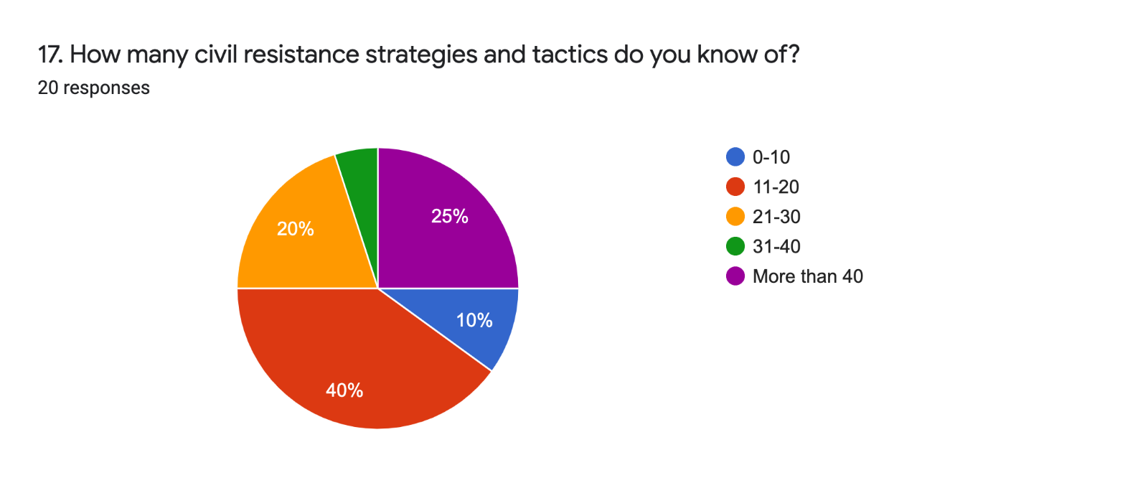

Pre-Course:
17. Please list any and all civil resistance strategies and tactics that you know of.

Too many to describe
Boycotts, strike, marches, protests, demonstrations, withholding of information eg survey or census; sit ins or occupations, breaking the law to provoke arrest
Mass protests, boycott, non-cooperation movements and petitions
Protest rally, consumer boycott, strike, symbols, alternative institutions, occupations, sit-ins, petitions, legal mobilization
I have known a few but cannot think of them right now. But that’s why this course is perfect!
Public speech Declaration / public statement Mass petitions Creating slogans or symbols Distributing leaflets or pamphlets Lobbying Mock election Vigils Marches Political Mourning Social boycott Consumers' boycott Class boycott Boycott election Strike Stay at home Protest meeting
Boycots, protests, leafleting, petitions, contacting government representatives, educating.
strikes, boycotts, civil disobedience, march past, and demonstrations,
None
Hunger strike, consumer boycott, petition, rejection of awards, protest, non tax compliance, mass resignation, use of pamphlets, slogans, music etc
Use of symbolic objects Sloganeering Petitioning Boycotts Demonstration Blockades Sit-ins Haunting Taunting Leafleting Postering Funeral mocks Use of puppets Public speeches Writing statements Press releases Canvassing Activation of international community Use of paint Wearing symbolic attires Strikes Marches Building parallel institutions Stand-in Sunctions Vigils Name shaming Earth writing Skywriting Hosting social events Public meetings Reach outs
protests,,,strikes,demonstrations
protest, strike, petitions to authorities
yes
Strike, boycott, fasting
Using VPM when the internet i shut down for civil mobilisation
protest, boycott, strike, march
Protest, Petition
b
Campaigns

Post Course:
18. Please list any and all civil resistance strategies and tactics that you know of.

Strikes, sit-ins, protests, petitions, march, boycott, and so on.

Boycotts / industrial action / student strikes / protests / marches / parades / rallies / public demonstrations / petitions / letter writing campaigns / open letters / signed letters and declarations / public speeches / use of slogans and chants / creation and wearing of symbols / production and use of banners and posters / publication and distribution of leaflets and pamphlets / circulation of articles of opposition / creation of newsletters / use of radio and television / group lobbying / picketing / making and using flags / mock elections / reclaiming of land, property etc / renaming of land, buildings, street signage etc / public prayers and worship / lobbying of officials (public embarrassment) / teach ins / sit ins / occupation of buildings etc / Sanctuary in the face of state repression e.g. protest against deportation of refugees by churches providing shelter / plays / vigils / use of candles and other lights / demonstrations at funerals / staged funerals / assemblies / social boycott / withdrawal of labour / stay at home / refusing to recognise state or public organisations or officials / withdrawal from state duties / withholding of rent / withholding of sex in marriages or relationships / social disobediance / non-cooperation / lockouts / reporting as sick / embargoes / refusing to purchase certain products / labelling products / refusing to be arrested / hunger strikes

Too many

Marches, sit-ins, petitions, persuasion, boycott, strike, fasting, picketing, protest etcetera.
Sustained, multitudinous participation, resilience in the face of repression, effective targeting the opponents, etc.

sit-in, vigil, occupation, strike, slowing down work etc., cultural resistance (i.e. through literature, theater, music, films, paintings, etc.), withholding sex, boycott, building alternative institutions, protest, demonstration, marches, spreading information secretly, teach-ins, staying away, omission, persuasion, jail-in, peaceful disobedience

Better coordination, good communication, strategic planning, strong leadershp , know the ennemy, building alliances and networks etct

Vigils, street demonstrations, marches, boycotts in all their variations, sit-ins, teach-ins, strikes (hunger, sex, work), creation of parallel institutions, subversive theater, parody, petitions, walk-outs, slowdowns, mock elections, caricatures, visual arts, singing, mock funerals, mock death bodies, singing and music playing, embargoes, non-obedience, non-cooperation.

protest, appeal, activist, campaign, media, documentary, art, civil disobedience, strike, seminar, boycott, march, etc
boycott, sit in, strike, petition, campaigns, demonstrations, marches
Strikes, boycotts, marches, demonstrations, and civil disobedience

sit-in, demonstration, vigil, alternative institution-building, coalition-building, petition, symbolic gestures, actions related to funerals, non-violence tactics training, strike, picket, distribution of flyers, alternative media, flash-mob, stay in home actions, road blockades

demonstration, strikes, political boycott, economic boycott, social boycott, petition, creating symbols, cultural resistance, making allies, parallel polis, etc.

Boycotts (act of omission) campaigns petitions sit ins cultural resistances alternative institional building strikes Disruptions protest/demonstrations post cards writings

Noncooperation and refraining tactics Strike, boycott, political and social noncooperation, silence Confrontational Acts Protest, march, conferences, conscientization, Constructive Acts Producing and consuming local products

Leafleting Petitioning Sit-ins Flash mob Striking Marching Building parallel structures Name shaming Earth painting Sky writing Postering Use of symbolic objects Funeral mocks Vigils Demonstrative funerals Kiss-ins Picketing Use of colour Teach-ins Laughtivism Blockades Boycotting Haunting Taunting Making public speeches Writing statements Use of effigies Stand-ins Artivism Cultural resistance Withdrawal from banks Refusal to pay taxes Nude protests Pray-ins Fasting Slow compliance Refusal to bails Use of alternative media Stay at home Mock elections Wearing symbols Mock wards Singing Religious processions

sit-in, protests, demonstrations, planning, discipline, etc
Strikes, Occupation, Petitions, Demonstrations, Alternative Government
satyagraha
Bycot,sanctios,picketing,sit ins,disobedience,language and story telling,posters and placard,art and inguenity,

Pre-Course:
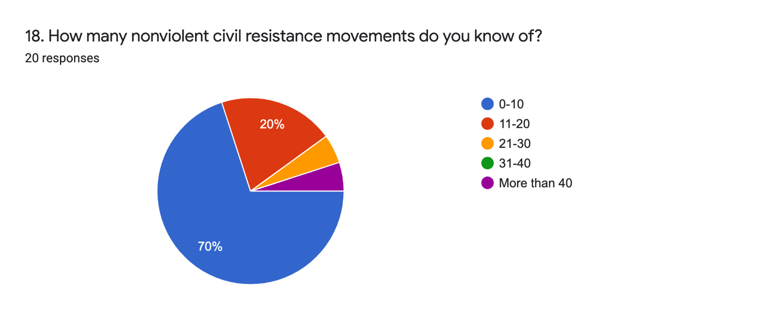

Post-Course:
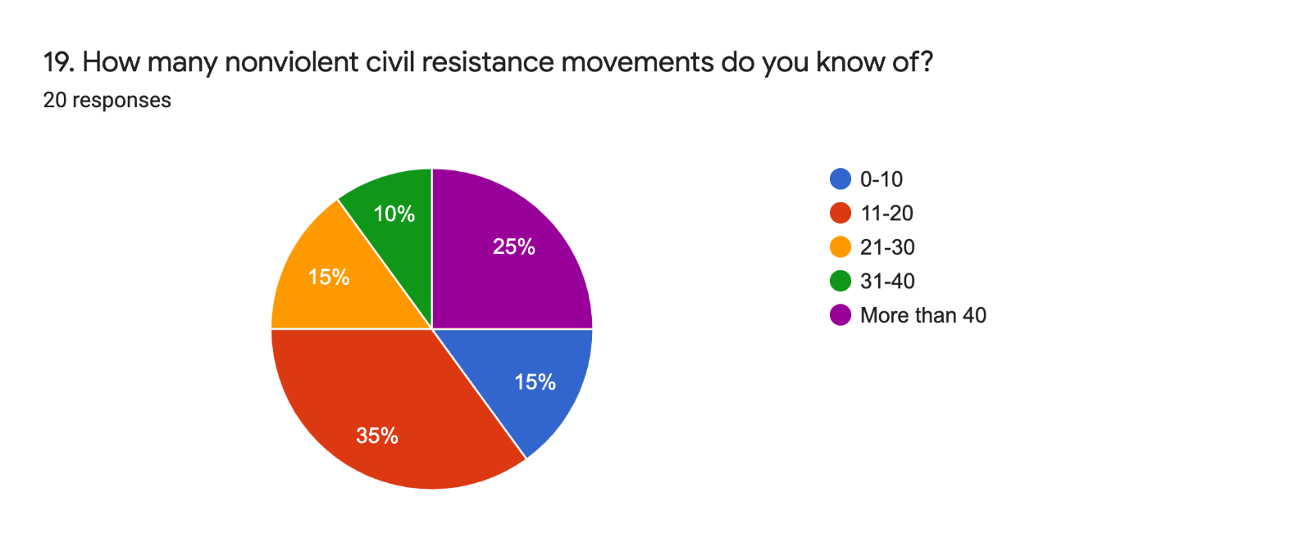

Pre-Course:
19. Please list any and all nonviolent civil resistance movements that you know of.

Too many to describe
Civil rights movement in India; US civil rights movement; NI civil rights movement; student demonstrations in US on gun control
Street protests, online strike, boycott, civil disobedience movement and defection of soldiers from military
Solidarnost' (Poland), Otpor (Serbia), Hmara (Georgia), Pora (Ukraine), Vesna Democratic Youth Movement (Russia), Vremya Movement (Russia), Open Russia, Feminist Anti-War Resistance (Russia), Students Against War (Russia)
Extinction rebellion, fridays for future, Ende Gelände, kvinnor för Fred, Ican, Bündnis gegen das Cyber Valley, dfg-vk, interventionistische linke, etc.
Umbrella Movement Occupying Wallstreet Sunflower Movement
East Timor Independence, India's Independence, Civil Rights Movement, Women's Suffrage, Pinochet dictatorship, Rosenstrasse, WWII's anti-Nazi movements in Denmark, Belgium, and Norway, end of Ferdinand Marcos regime.
Native Consortium
Civil Rights Movement, Salt March, Orange Revolution, Arab Spring, Sudan Revolution
The orange revolution of Ukraine, the salt walk in India led by Ghandi, Endsars protest, black lives matter movement etc
Black lives matter Ortpor EndSars Students for democracy Civil rights movement Nonviolent Students Coordinating Movement Mothers Against Police brutality Gay rights movement People power movement Green peace Migrant farm workers movement Poor people's campaign
picketing,sitins,boycots,peaceful demonstrations
Underground Railroads, BLM, End the war in Vietnam, Singing Revolution in Baltic states, School strike for climate
Farmers agitation
Black Lives Matter
LUCHA
March in Washington, Black Umbrella protest
people power movement in Uganda (NUP) The civil right movement of 1965 in the US
protest, boy cotts, sit in, marching, campaigns
#endsars campaign

Post-Course:
20. Please list any and all nonviolent civil resistance movements that you know of.

Civil Rights Movement, Salt March, Orange Revolution, Arab Spring.

Iceland women's revolution / de-segregation of buses in Israel / resistance against the occupation of the Ruhr Valley / protest against mining in Kenya / Amazonian tribes resistance to mining and development in their lands e.g. Zingu peoples' resistance / occupation in Woodburn forest against oil exploration, Northern Ireland / resistance to mining in the Sperrins, Northern Ireland / protest against poor housing in Donegal, Ireland / Irish language rights movement, Northern Ireland / UCU industrial action in the UK / civil rights movement in the US / civil rights movement in Northern Ireland / Peace People in Northern Ireland and wider UK / Bengali language movement / boycott movement in 19th century Ireland / reproductive healthcare movements across the island of Ireland / marriage equality movements across the island of Ireland / coalition for the banning of conversion therapy across the island of Ireland / rent strike in Belfast / Danish resistance movement during WWII / Norwegian resistance movement during WWII / resistance movements against Nazi regime in Germany including White Rose movements / Extinction rebellion in the UK / student protests in 1968 on an international scale / women's suffrage movements in US, UK, France etc / Heathrow 13 protesters / People Power movement in the Philippines / Standing Rock movement / Catalan independence referendum / Stansted 15 protesters / Yarl's Wood hungers strikers / White Wednesdays in Iran / Syrian Uprising / Sudanese protests / Indian farmers protests 2020-2021 / Umbrella revolution in Hong Kong / Libyan protests / Egyptian revolution / Orange Revolution, Ukraine / Palestian resistance movement / Rose Revolution in Georgia / Velvet Revolution in the then Czechoslovakia / Solidarity movement in Poland / Gandhi nonviolent movement in India / Tiananmen Square protests 1989

Too many

Anti Haq movement, Uruguay's 1973 anti dictatorship campaign, Chile 1983 anti dictatorship campaign, 1971 Bangladesh movement for sovereignty, Algeria and France 1961 anti coup struggle, Ghana's 1949 self determination struggle, Elsalvador anti Martinez protests 1944, Movement for the emancipation of Ogoni land against Shell cooperation 1993, Resisting Nazi occupation in Norway 1942, Liberian women sex strike, etcetera..

Non-operation movement, sit-in, petition, boycott, mass protest, hunger strike, cultural resistance, defection, etc.

lunch counter protest, freedom riders, nvr in syria, liberia, mali, egypt (tahir square), pakistan, india, women in black (palestine and elsewhere), zimbabwe, kenya, nepal, occupy wallstreet, first intifada in palestine, solidarity movement (poland), ende gelände (germany), bündnis gegen das cyber valley (germany), tulip revolution, rose revolution, orange revolution, cedar revolution (lebanon), otpor (serbia), extinction rebellion, fridays for future, mothers of the plaza de mayo, thai protests, danish resistance against german nazis, banging brigade (myanmar), singapur civil resistance, black lives matter, kvinnor för fred (sweden), interventionistische linke, deutsche friedensgesellschaft- vereinte kriegsdienstgegnerInnen (dfg-vk; germany), …

Orange Movement in Ukraine, Anti-appatheid movement in South Africa, the civil resistance in the DRC, the ivil reistance in Argentina, Mexico ect

Civil Rights Movement led by MLK, Jr., India's Independence led by Mahatma Gandhi, Rossentrase, the campaign against Pinochet regime, Mother of Plaza de Mayo, Birmingham Bus Boycott, Malala Yousafsai's campaign for girls education in Afghanistan, Venezuela's Pemon People against tourism industry in their lands, campaign against Ferdinand Marcos, the Orange Revolution, the Arab awakenings of Tunisia, Egypt, and Syria, the campaign to overthrow Gen. Marcos Perez Jimenez in Venezuela, the Green Belt Movement, Poland's Solidarity movement, the overthrow of Sudan's General Ashad, Colombia's peaceful resolution between government and FARC guerrilla, Denmark's opposition to Nazism during WWII, the campaign against South Africa's apartheid regime, Pashtun movement, Bolivia's campaign against privatization of water access, the Velvety Revolution,.
2020 Thai Protest, 2019 Algerian Protest, 2016 Candlelight Protest in Korea, Umbrella Revolution in HK, etc
the 1989 revolutions, postwar anti-colonial movements, The Arab Spring

India Shaheen Bagh protest, Boğaziçi University protest, Sierra Leone Fuel Increment protest and Thai Protests

Solidarnost (Poland), ADEMA (Mali), Khmara (Georgia), Pora (Ukraine), Otpor (Serbia), Civil Contract (Armenia), Committee of Soldiers' Mothers (USSR/Russia), Vesna (Russia), Civic Forum (Czechoslovakia), Civil Rights Movement (US), Pulse (Nabd) (Syria)
HK Umbrella movement (2014), HK anti-extradition bill movement (2019), HK primary election (2020), Taiwan Sunflower movement (2014), Ukraine Orange Revolution (2004), Ukraine Maidan Uprising (2013), US Civil Right Movement (1950s-60s), US Occupying Wall Street (2011), US BLM (2020), Egypt Revolution (2011), Tunisia Jasmine Revolution (2010), etc.
The American civil rights movement (1960) El Salvador: The Anti Martinez Campaign 1940-1944 France: Le Chambon Protection of Jews Indonesia: CICAK and the KPK an corruption Eradication commission NORWAY: RESISTING NAZI OCCUPATION UNITED STATES: NATIONAL WOMEN'S PARTY CAMPAIGN FOR SUFFRAGE UNITED STATES: STUDENTS AGAINST SWEATSHOPS EL SALVADOR: ANTI-MARTINEZ CAMPAIGN IRELAND: PEACE PEOPLE CAMPAIGN Quit India movement by Ghendi

Black Lives Matters, Y' en a marre, Le Balai citoyen, Lucha.
Mothers of the disappeared Students for Democracy Green belt movement Orptor Black pathers Nonviolent Students Coordinating Committee Civil rights movement Southern Christian leadership fellowship Poor people's campaign Black lives matter movement People power movement National Association for Advancement of colored people Mothers against drunkard drivers Campaign zero March on Washington movement Black Power movement Peace movement Catholic worker movement Jasmine revolution Muslim brotherhood Orange revolution Velvet revolution Worker student alliance National mobilization Committee to end war in Vietnam occupy movement Anti-apatheid movement Truth movement Farm worker movement March for our lives Landless people's movement Salt March Occupy wall street Umbrella movement South African Unemployed people's movement Sunrise movement Women's suffrage Women against war Global justice movement Lawyer's movement in Pakistan Reform movement Mee too movement Solidarity movement

#ENDSARS, 3BringBackOurGirls#, etc

United States Independence Struggle, Filipino women end violence through sex strike, One minute darkness for constant light in Turkey

4 movements led by Dr. Martin Luther King Jr.

Maji Maji Rebellion(tanzania),Mau Mu Rebellion,Politicl women Caucus,cHAM CHA MAPINDZUZI,Uwangano intitiave(all kenya),Kenya liberation movement etc

Pre-Course:
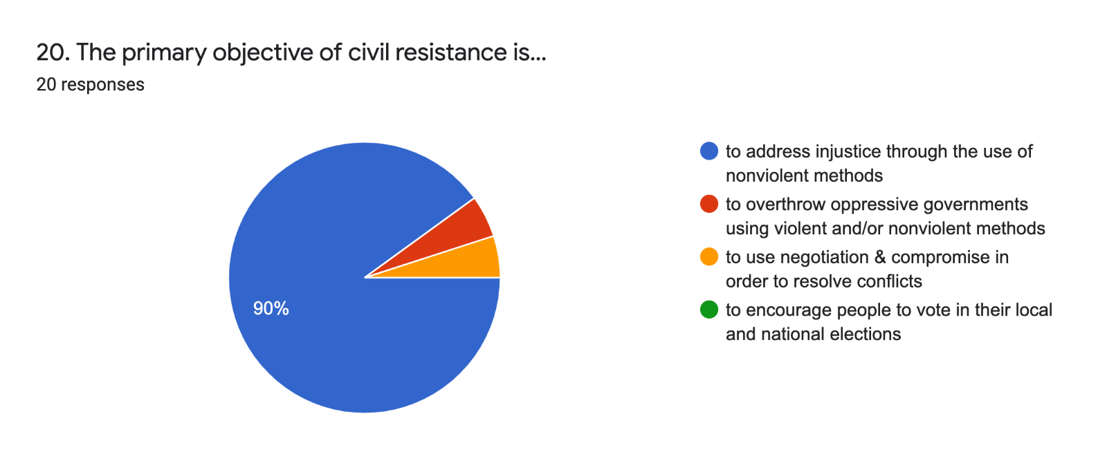
Post-Course:
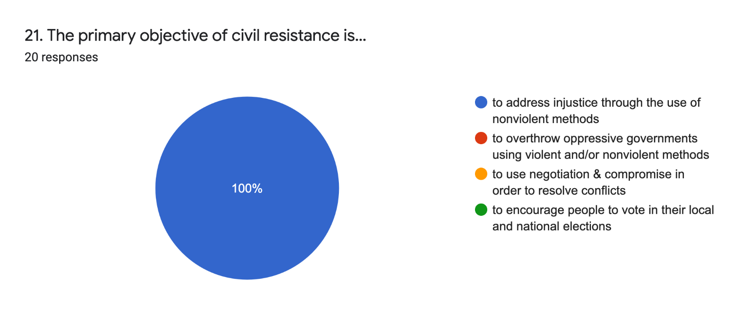

Pre-Course:
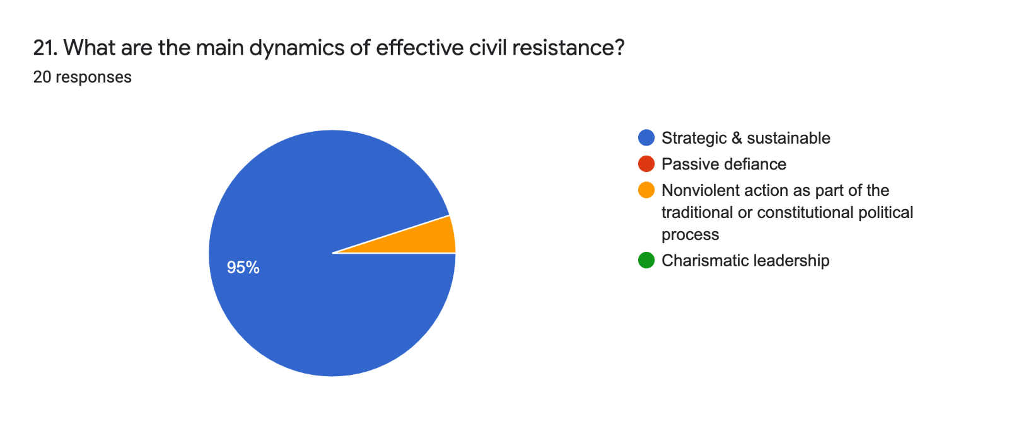

Post-Course:
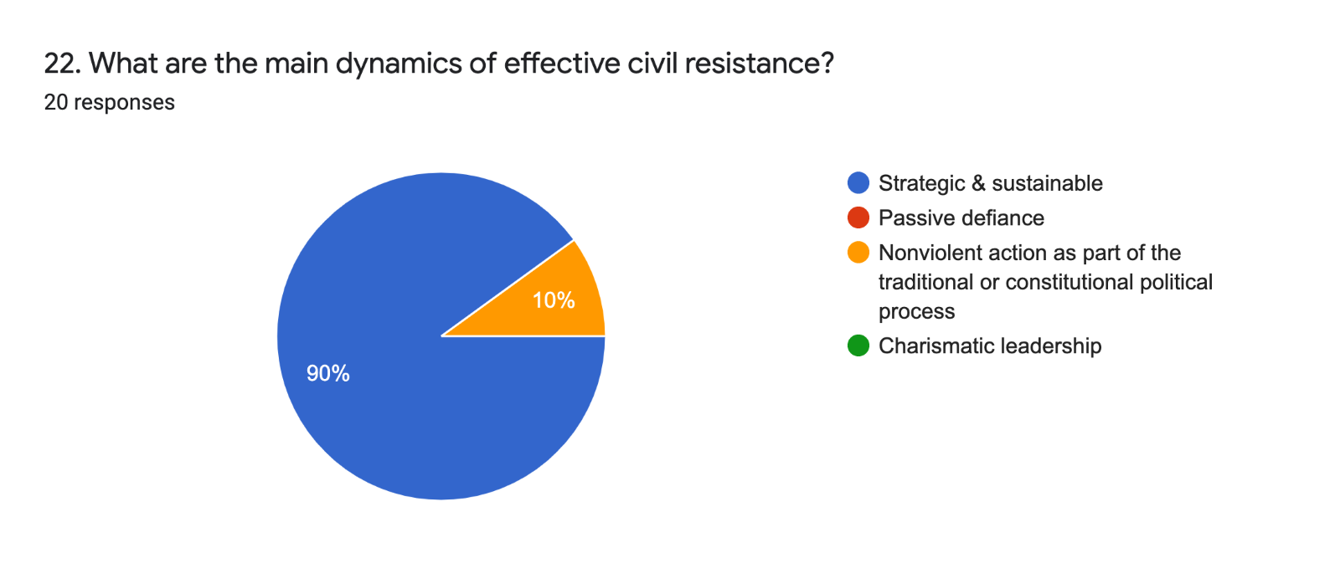

V. Attitude/Belief about Civil Resistance
Pre-Course:
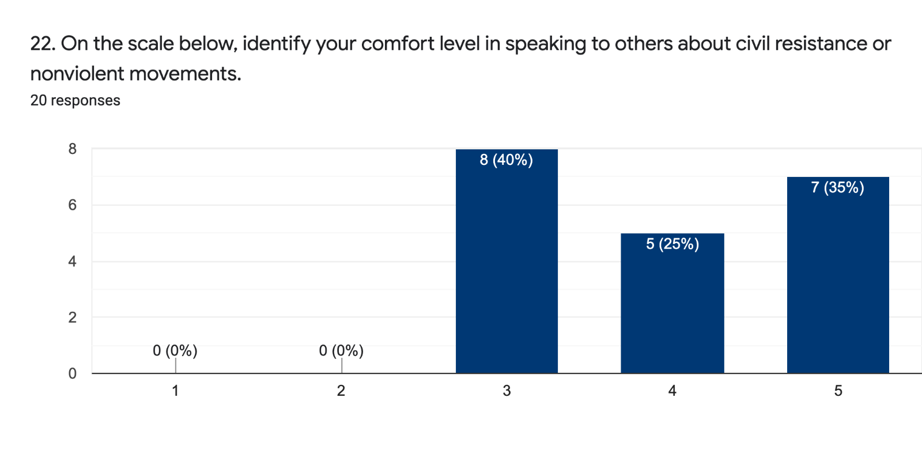
1= Not at all
5= Very comfortable

Post-Course:
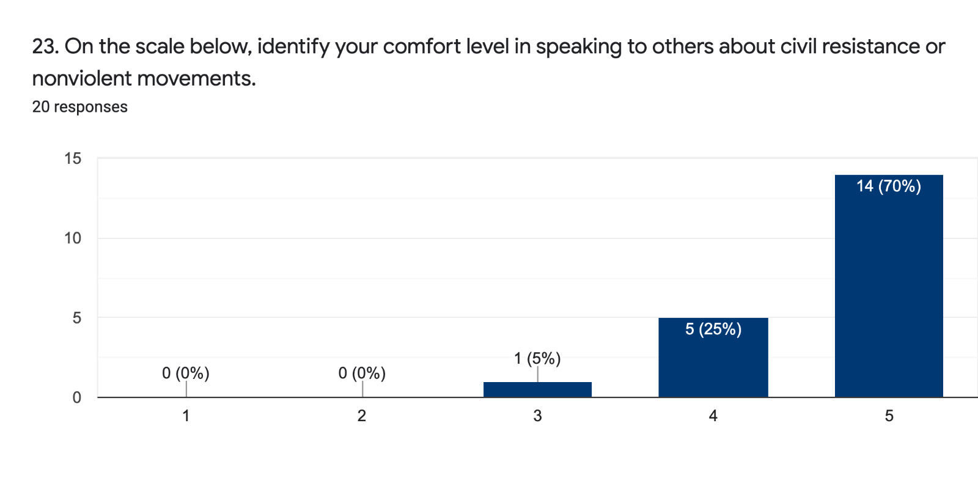1= Not at all
5= Very comfortable

Pre-Course:
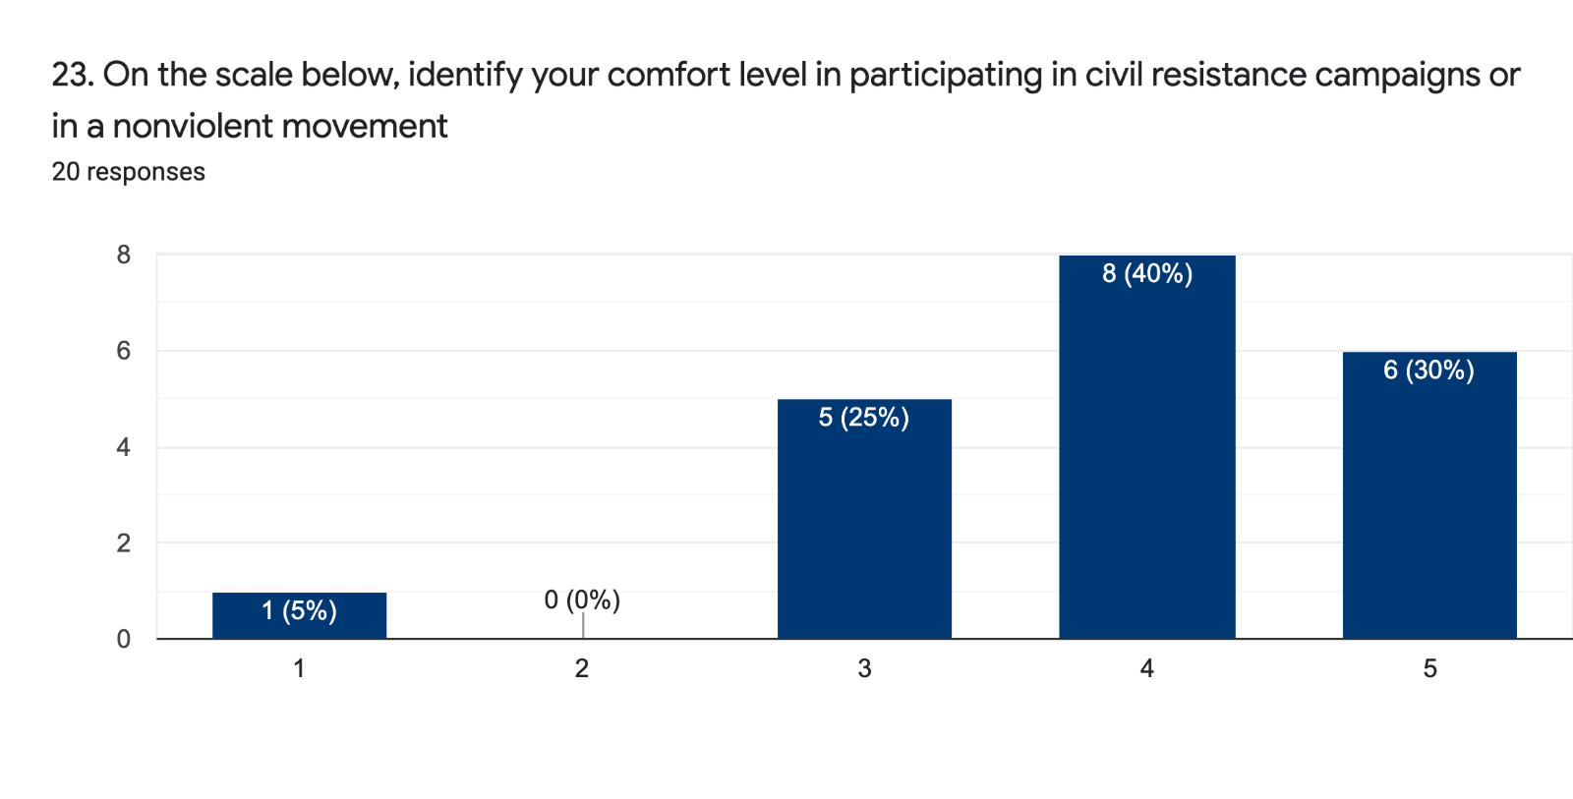
1= Not at all
5= Very comfortable

Post-Course:
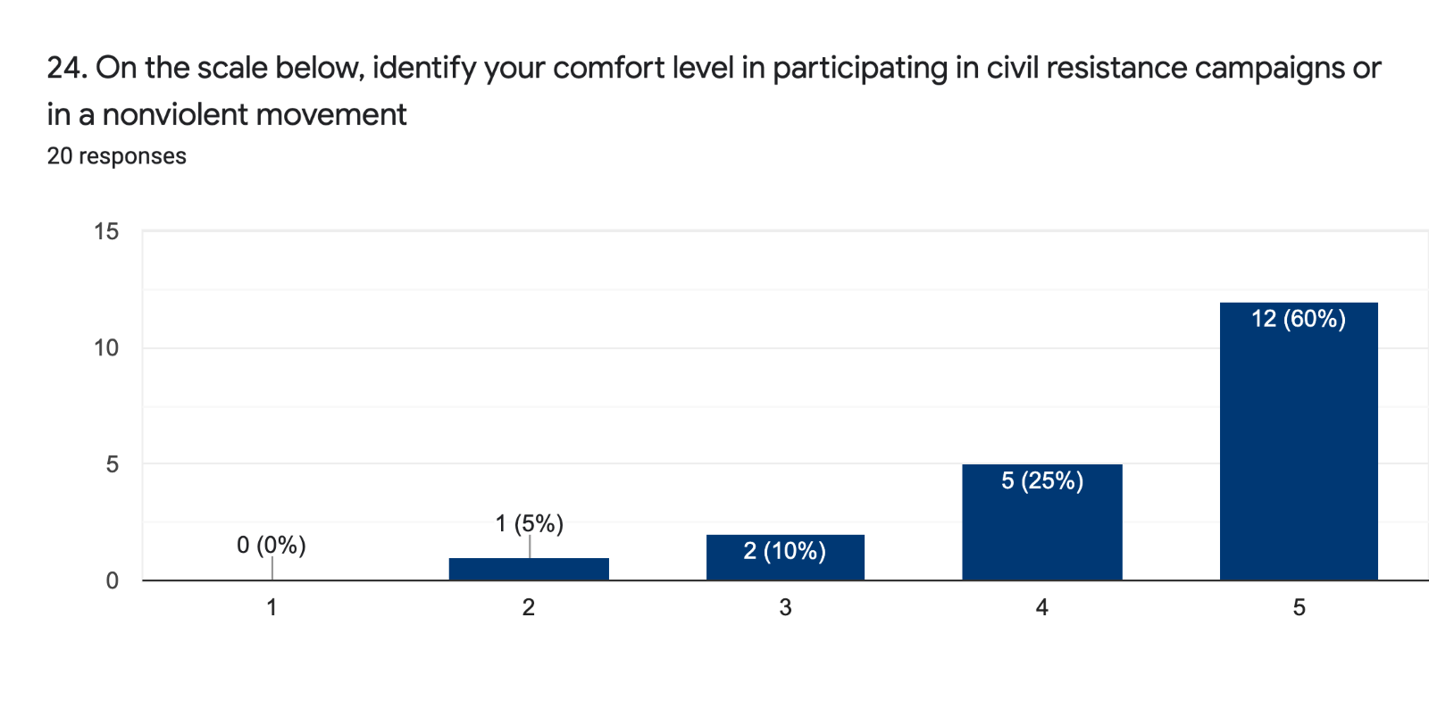
1= Not at all
5= Very comfortable

Pre-Course:
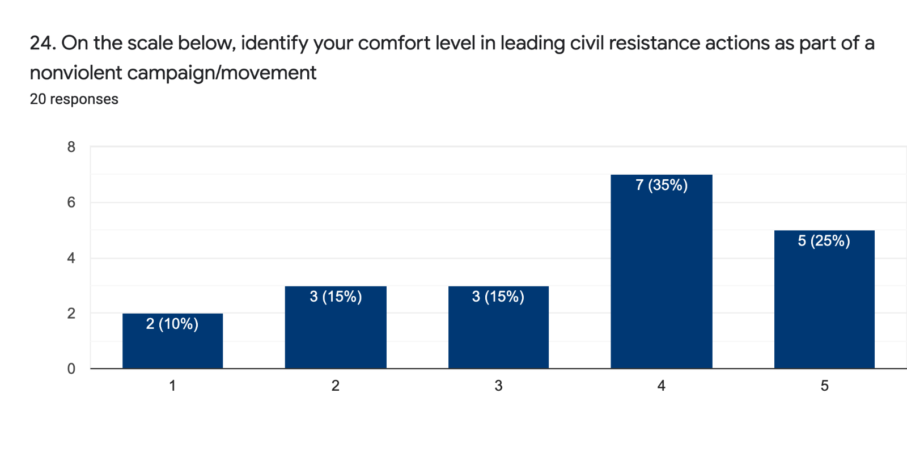
1= Not at all
5= Very comfortable

Post-Course:
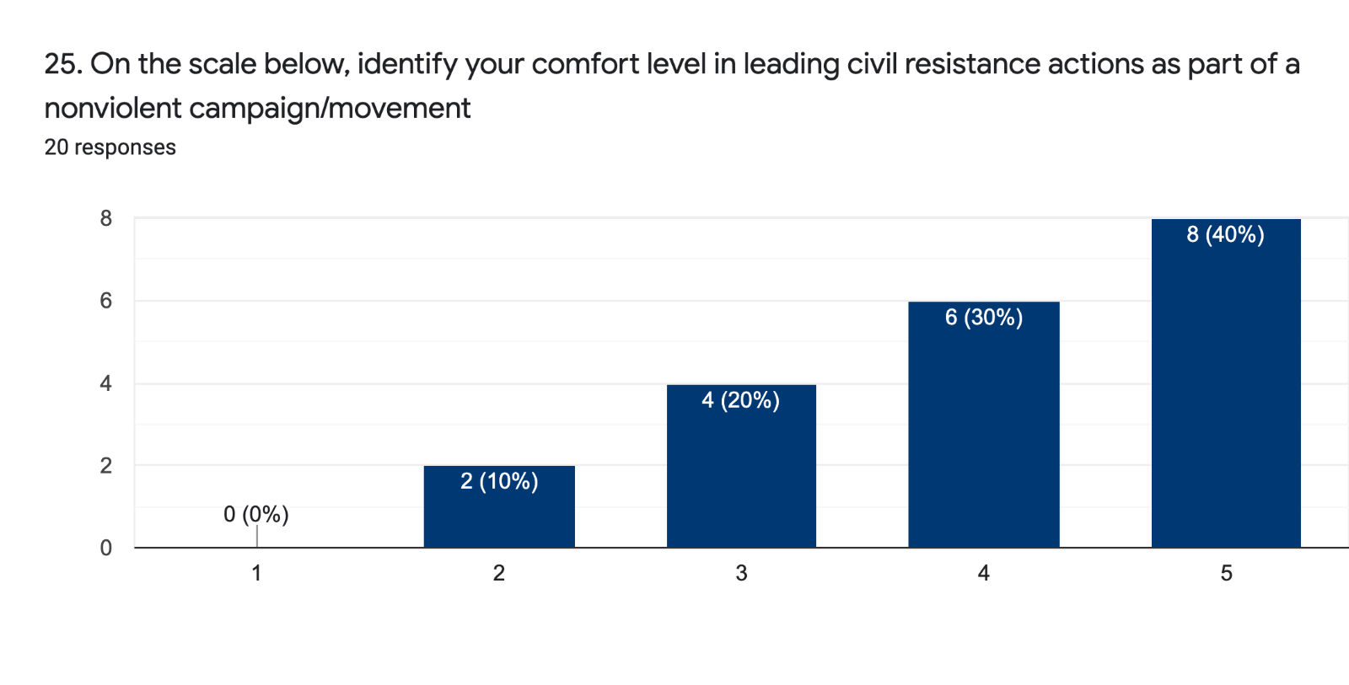1= Not at all
5= Very comfortable

Pre-Course:
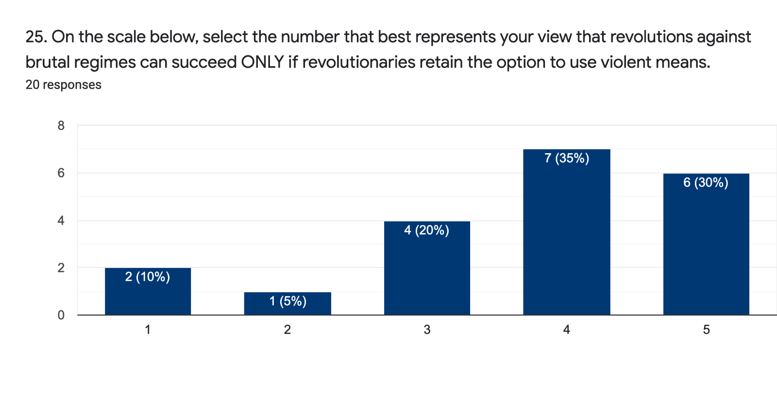
1= Strongly agree
5= Strongly disagree

Post-Course:
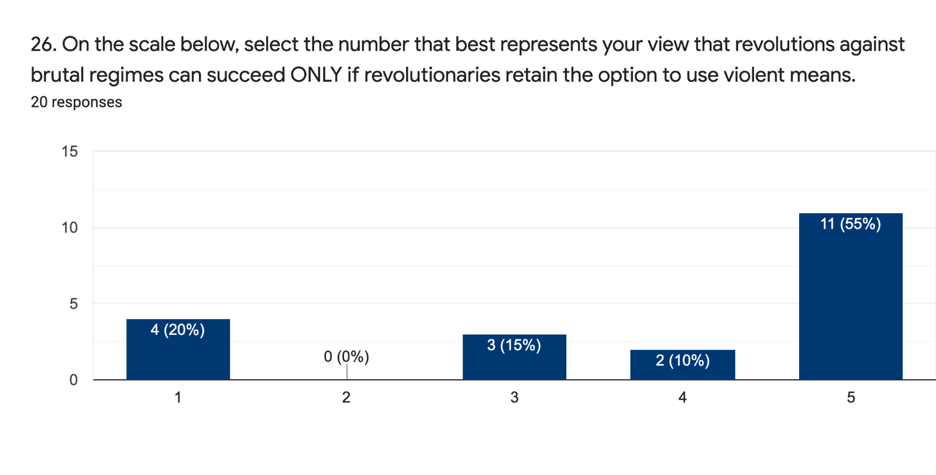
1= Strongly agree
5= Strongly disagree

Pre-Course:
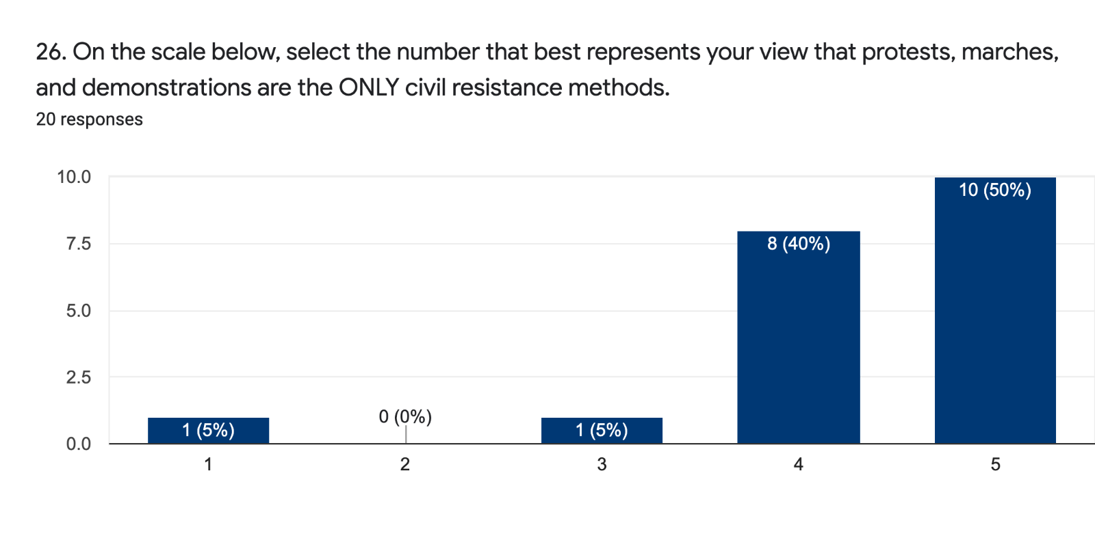
1= Not successful
5= More successful than not

Post-Course:
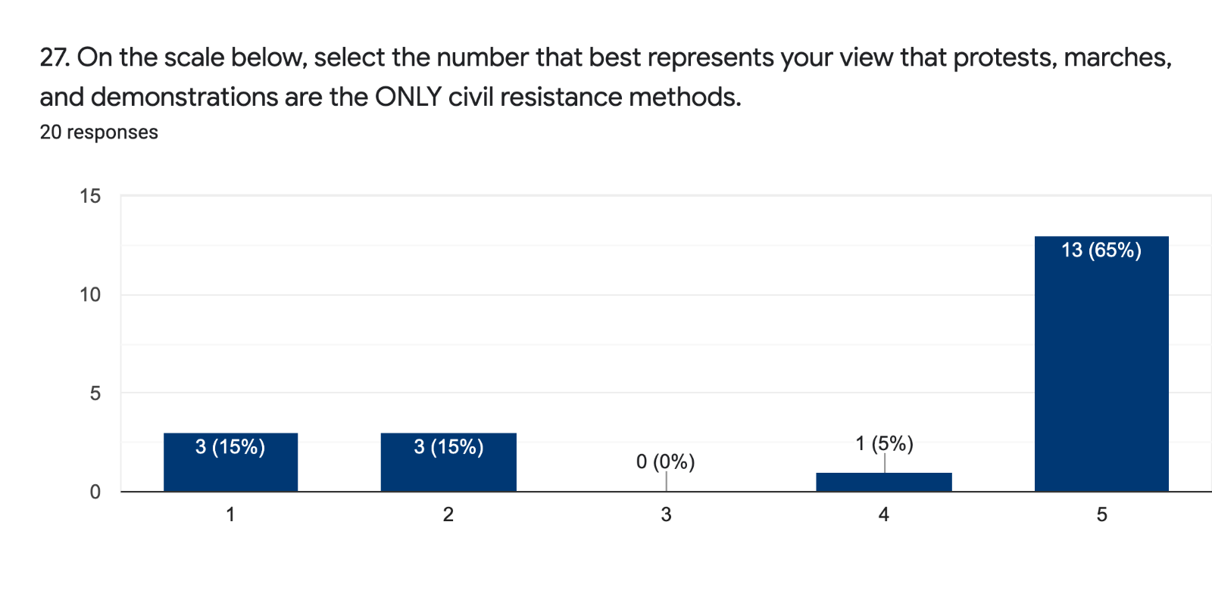
1= Strongly agree
5= Strongly disagree

Pre-Course:
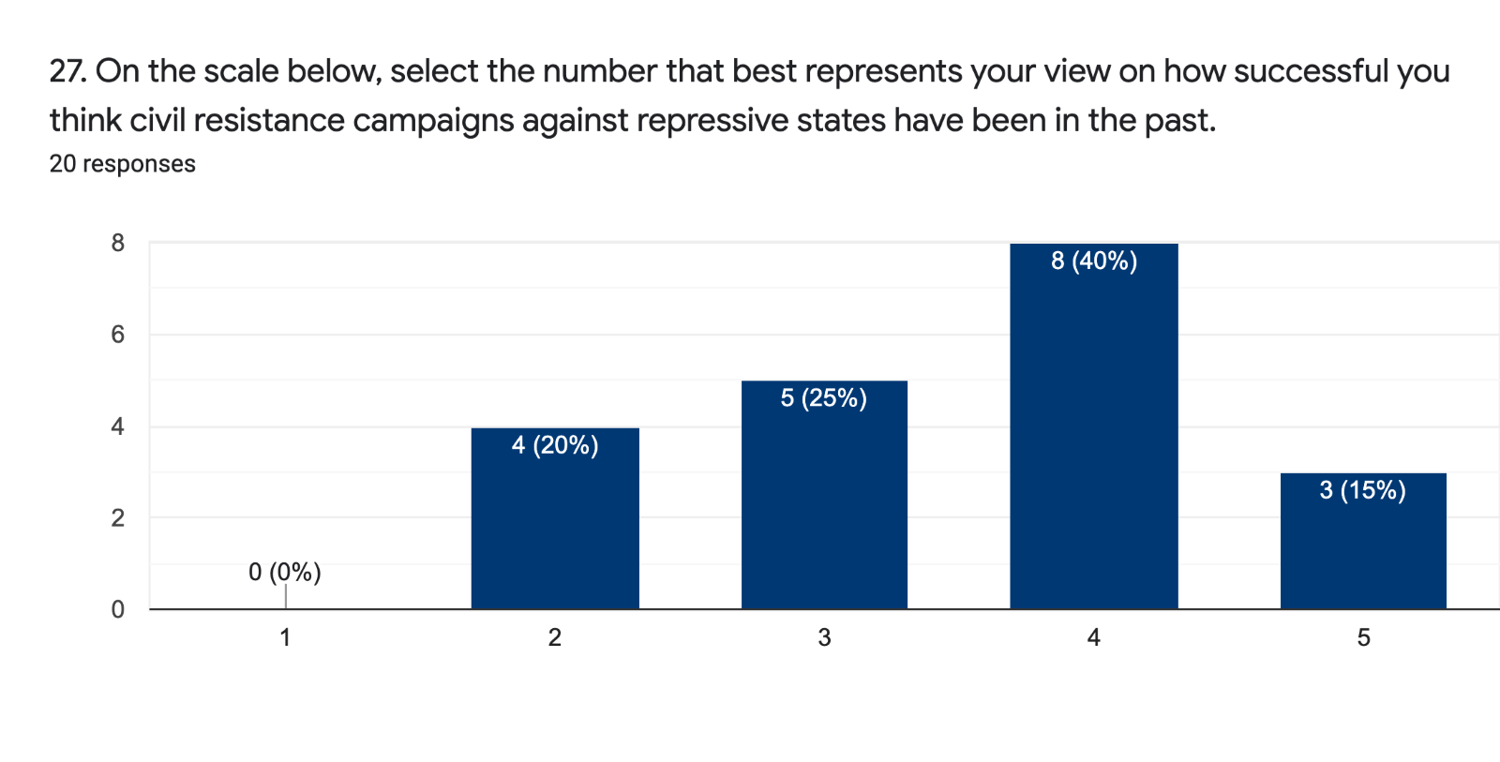
1= Not successful
5= More successful than not

Post-Course:
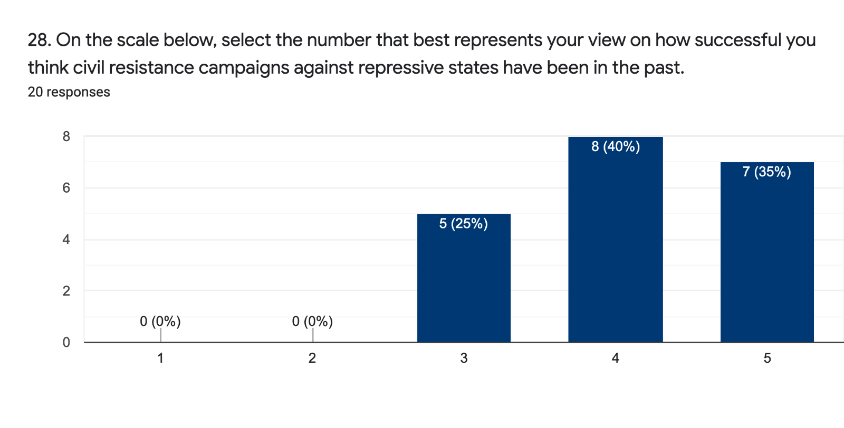
1= Not successful
5= More successful than not

Pre-Course:
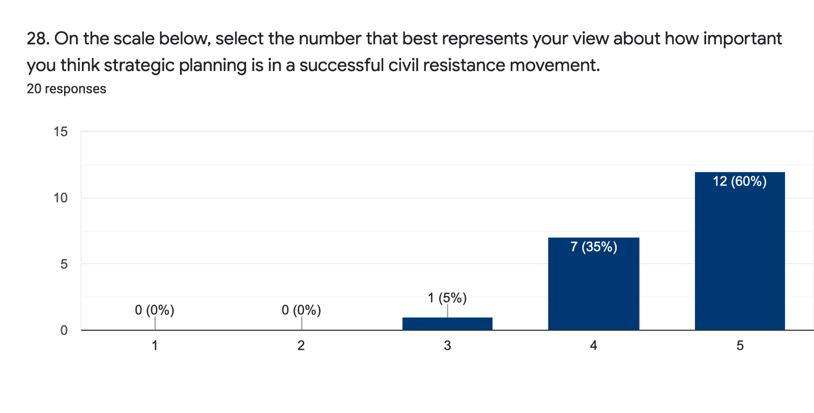
1= Not at all
5= Extremely important

Post-Course:
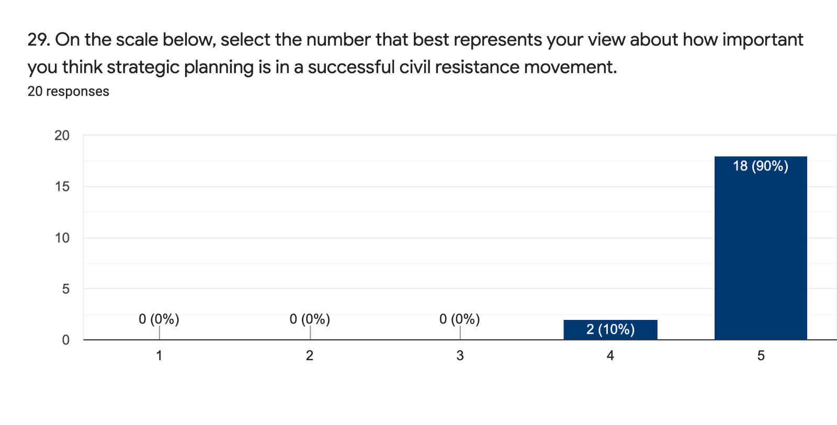
1= Not at all
5= Extremely important

Pre-Course:
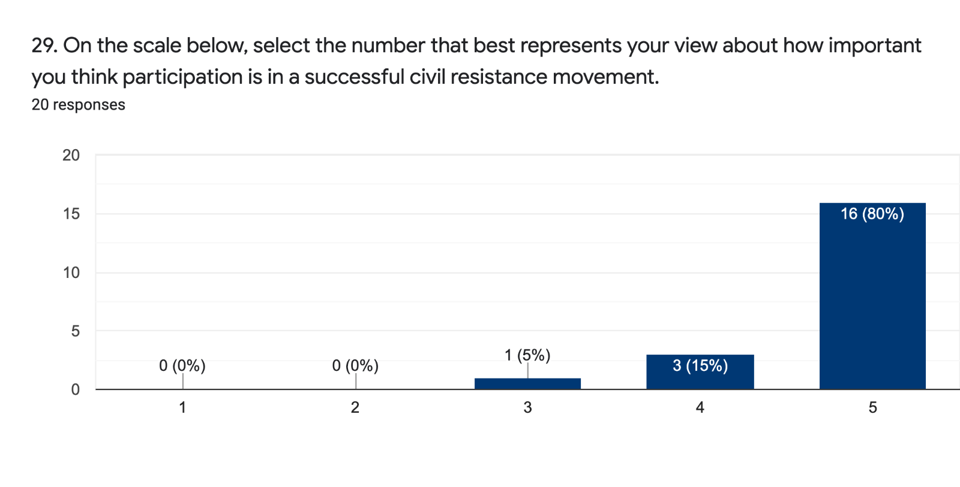
1= Not at all
5= Extremely important

Post-Course:
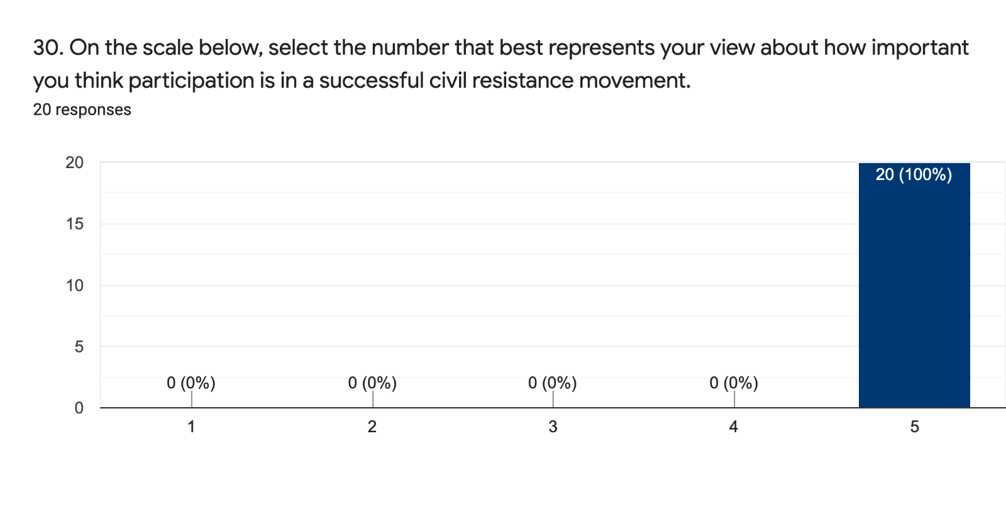1= Not at all
5= Extremely important

Pre-Course:
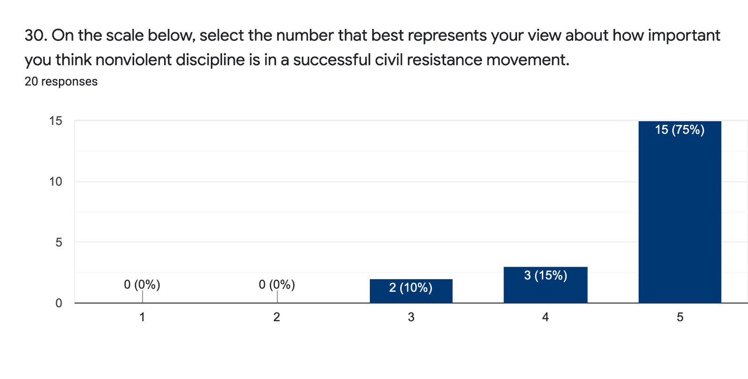
1= Not at all
5= Extremely important

Post-Course:
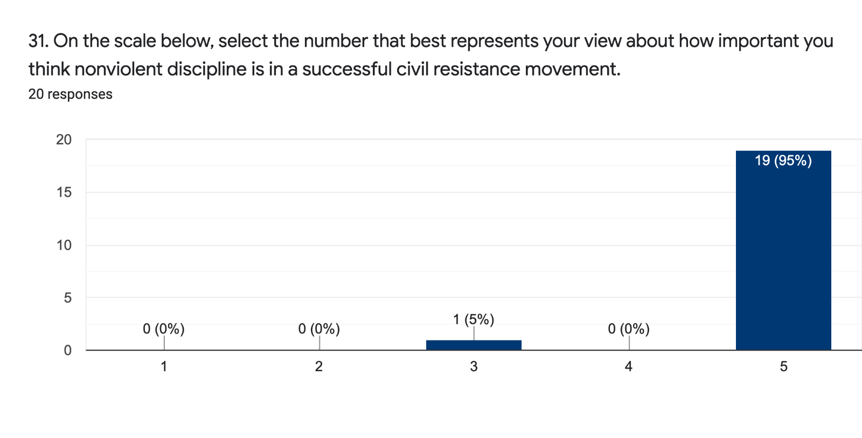1= Not at all
5= Extremely important

VI. Course Platform and Device
Pre-Course:
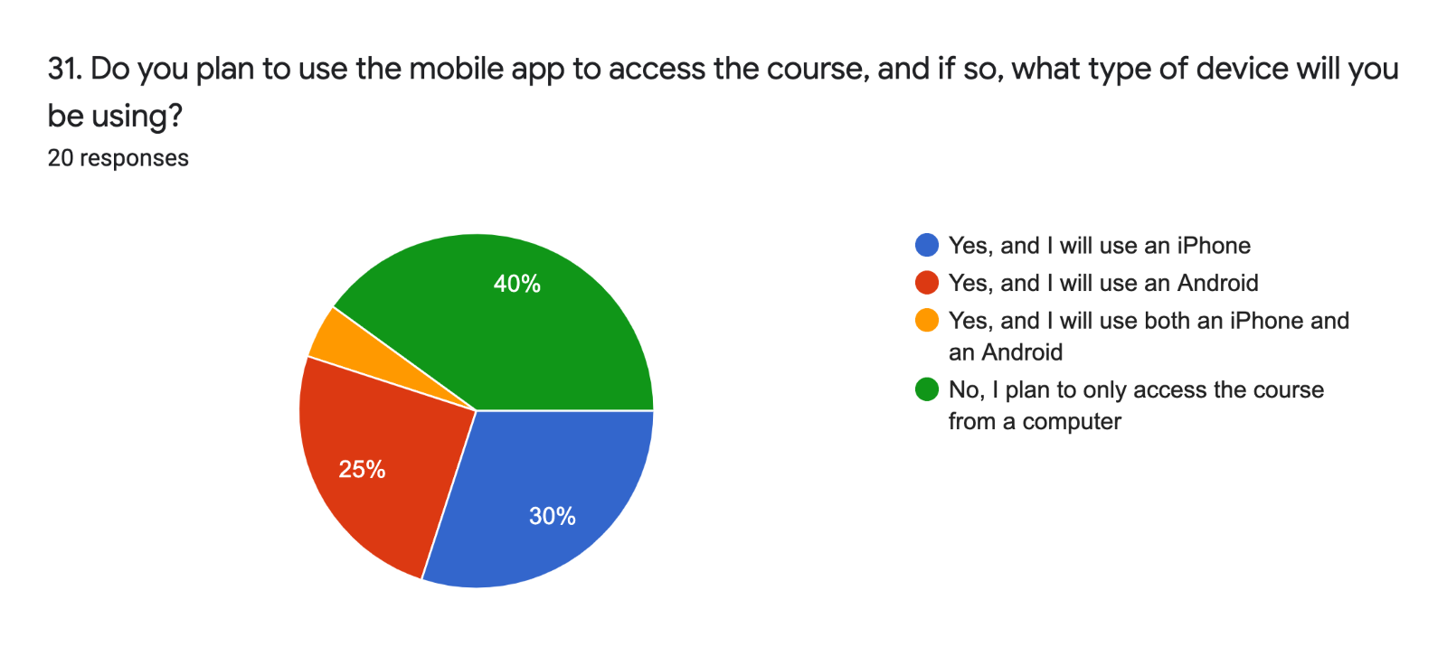

Post-Course:
